
How to Build a Desktop PC – Part 2 (Example 2)
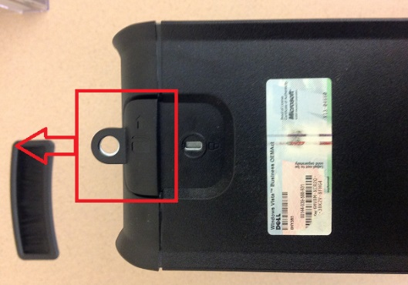
Pull back the tab at the back of the computer. The side panel will become loose. Pull off this panel to access the computer parts.

- CPU (Central Processing Unit) – under the heatsink
- Optical Drive on top w/ a 3.5’’ floppy disk drive under that, then the Hard Drive at the bottom
- PSU (Power Supply)
- RAM (Random Access Memory) and extra RAM slots
- PCI expansion slots with a GPU (Graphics Processing Unit) installed
- SATA ports

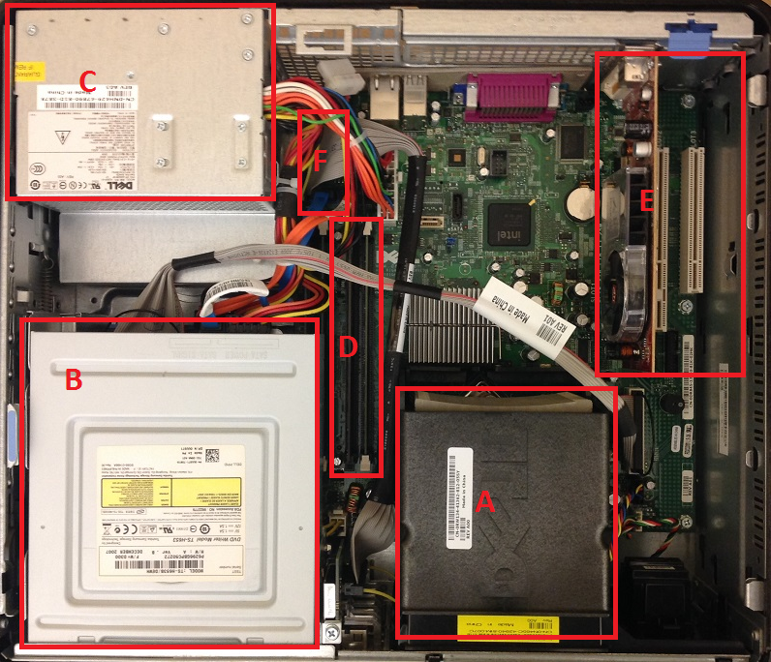

Disassembly Tips
- Use your smart phone to take pictures of the computer assembled that way you can look back at the pictures for reference during assembly. (Pictures provided on handout as well)
- Remove screws and place them on paper. Circle the screws and label where they came from.
- Before touching computer hardware touch your hand to metal to ground yourself to avoid electric shock damage.
- Be gentle when removing parts:
  - Avoid dropping parts
  - Avoid placing them on top of each other
  - Avoid slipping with the screw driver. Scratching a board can destroy it
  - Avoid placing parts on top of metal or places where it could easily fall
  - Place the removed items out of your way to avoid bumping or damaging them
- If your computer is dirty this is the best time to clean it with compressed air.
- Remember what order you removed parts you will need to assemble them in reverse order

Assembly Tips
- Before touching computer hardware touch your hand to metal to ground yourself to avoid electric shock damage
- Be just as gentle assembling the computer as disassembling to avoid damage.
- Put things back in the order you took them out
- Nothing was designed to need force. If you need to add force to make something fit, then try assembling it another way.
- After assembly always double check to make sure all screws are in. Do not close your computer before all screws are back in place
- Double check to make sure all cords are in the correct place and fully/properly connected.
- Plug the computer in and make sure it is fully functional. Never touch or work on the computer while it is on!
- Once you have checked over your work and it functions as intended close up your computer.

