
Cutting the Cable Cord
Services | Cost | Content | Resolution
 | $7.99-11.99 per month | TV shows, movies, and original content | Standard HD and 4K (depends on subscription)
 | $7.99 or $11.99 per month (no commercials) | TV shows, movies, and original content | Standard HD
 | $99 a year or $10.99 per month | TV shows, movies, and original content | Standard HD
 | Free, but has commercials | TV shows and movies | No HD content
 | $14.99 per month | Movies and original content | Standard HD
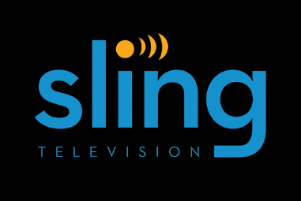 | Packages range from $20-40 per month | Choose your television channel (Bravo, FX, ESPN, etc.) | Standard HD
 | Packages range from $40-75 per month | Choose your Television channel (Bravo, FX, ESPN, etc.) | Standard HD
 | 5 Checkouts per month with library card | TV shows and Movies | Standard Resolution
Google Play, Vudu, iTunes, etc. | $1.99 and up per item | TV shows and Movies | Standard HD and 4K (depends on title)
Devices | Cost | Pros | Cons
HD Antenna | $12-150 | Up to 50 free Channels | Limited Content
Roku Stick | $40 | Low price | Only HD content and a little slow
Roku Premiere | $80 | Cheapest 4K device that supports apps | Needs 25mbps internet or faster for 4k
Roku Ultra | $130 | Supports HDR/4K | Not much 4K or HDR content available
Apple TV | $150-200 | Fast & contains Apple’s easy-to-use interface | Generation three and earlier does not support 4K/HDR
Fire Stick | $40 | Low price | Only has Amazon app store
Fire TV | $90 | Supports most streaming apps. 4K support when available | Needs 25mbps internet or faster for 4K and only has Amazon app store
Video game consoles (Xbox One, PlayStation 4, Wii U, etc.) | $150-400 | All entertainment in one device | Available apps are limited compared to other options
Smart TV/Blu-ray player | $250+ | All in one | Depending on the brand, some apps not supported
Chromecast | $35 | Cheapest streaming device | Needs another device for Chromecast to work
Chromecast Ultra | $70 | Cheapest 4K/HDR streaming device | Needs 25mbps internet or faster for 4K and another device for Chromecast
Computer in a stick plus wireless mouse & keyboard (intel stick, Chromebit) | $80-150 for stick  $30-60 for mouse and keyboard | Provides full computer/Chromebook functionality | Most expensive and complicated option. If not tech savvy, might not be  the best choice.
ADDITIONAL RESOURCES
- Interested in the pros and cons of cutting the cable cord? bit.ly/2hKGqcO, bit.ly/2cmyzjT, bit.ly/1rRLhCe or bit.ly/2lOVapM
- Need to check your Internet speed? www.speedtest.net
- Is this show/movie available for streaming? www.canistream.it or www.justwatch.com/us

