
Activity Sheet: Customizing Your Resume Part 2

ACTIVITY #1
Review the Customer Service Manager job posting listed below. Underline the important and/or transferable skills they’re seeking in applicants.
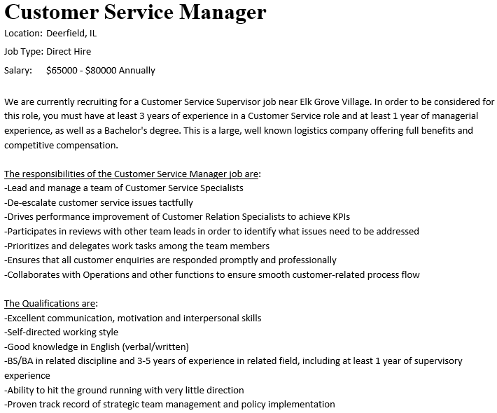

ACTIVITY #2
Open your saved resume (or the resume template of your choice, if you don’t have it with you) and begin entering the appropriate information into the Work Experience section.

ACTIVITY #3
Using your saved resume or the resume template of your choice, begin entering the appropriate information into the Education section.

ACTIVITY #4
Using your saved resume or the resume template of your choice, create any additional sections needed for your resume and begin entering the appropriate information.

Note: If you want to keep this evening’s work, be sure to save your file to a flash drive, Google Drive, OneDrive, or email it to yourself.

