Craigslist Basics

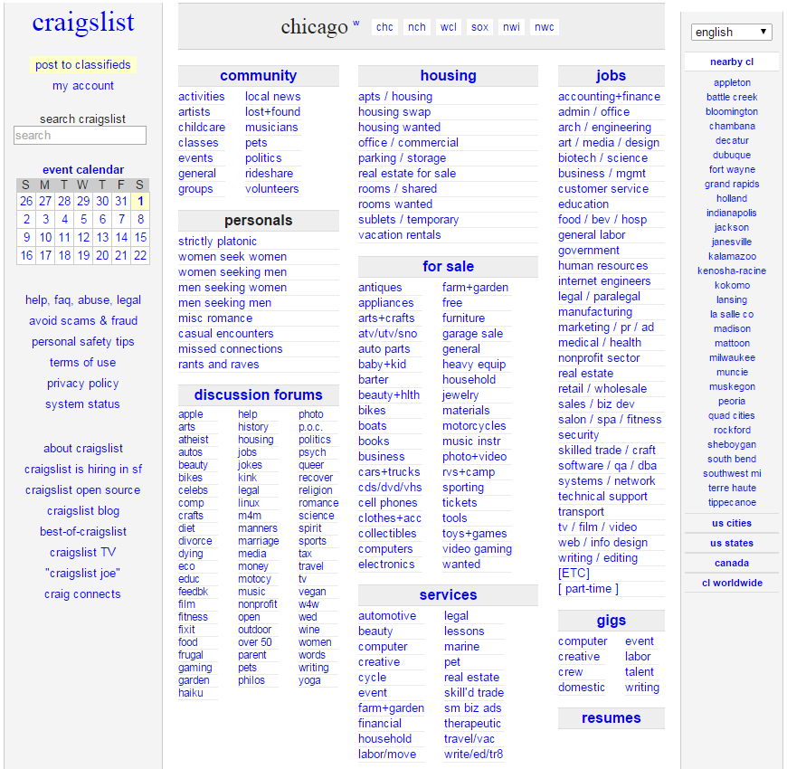
Create ads to post
Choose your location
Current ads by category
Craigslist help, policies, safety tips, & other site specific info
Nearby major cities & other locations

SAFE TRANSACTION TIPS
•Pay with cash or request a trade. If you want to use another form of payment be aware of the risks involved and make sure both parties agree before you meet to make the exchange.
•Once you have agreed on a price and payment method, pick a convenient location for the exchange. Meet at a public location during the day to decrease risk, like a police station lobby or cafe. If possible, bring a second person with for safety reasons and/or to advise you on your purchase.
•Always examine the item before purchasing it. Make sure you are receiving exactly what was agreed upon before any money changes hands. For electronics, make sure your meeting place has power outlets so you can test the product.
•When dealing with large transactions, invest in a marker to test large bills for fakes.

AVOIDING SCAMS
•Be skeptical of anything that is far below current sales prices. These ads are not always fake, but if it looks too good to be true, it likely is.
•If someone speaks or writes in broken or poor English there is a good chance they are a scammer from a foreign country. Avoid these ads or proceed with caution.
•If the person expects you to ship the item first or wants you to pay for a purchase before you can examine the item via money transfer, mailed check, PayPal, etc. they are likely a scammer. Even if they are not a scammer, you have no protection if they renege on the deal.
•If the person becomes threatening or demanding stop talking to them. Unless money has been transferred or you signed a contract you can always back out.

