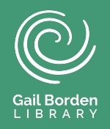
Segoe UI Semibold 16pt, 1½ bottom Paragraph Border
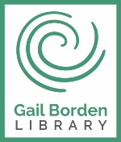
GBPL Logo at end of line
Green fill for Handouts
White fill for Activity Sheet
Height: 0.80; Width: 0.68
Use CMYK version for printing
Section Header (Segoe UI 12pt, Bold)
Body Text (Segoe UI 11pt).
Helpful to put in text box with no outline to easily move it around the page.

Text/Highlight Box & Images
Used to highlight a particular area in an image or to include text next to an image
Segoe UI 11pt, bold. Black border (unless color is needed – colors that match GBPL’s theme are preferred), 1pt outline, no fill
Position > With Text Wrapping > In front of text

ALWAYS put images In front of text so you can move them freely throughout your document
Images should have a border (Black, ¾ to 1pt outline)
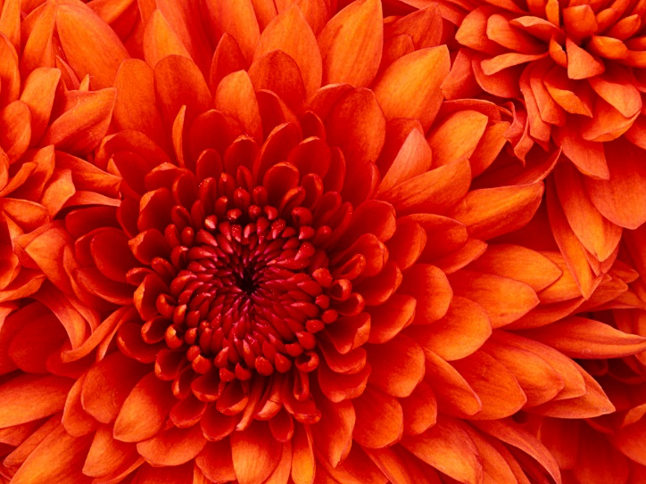
Margins can be custom (No more than 1’’). Narrow is preferred.
Footer uses blank three column format in Segoe UI 9pt for Author Initials, Gail Borden Public Library District, and Month/Day/Year document was last updated.
Example
Chrysanthemum

