
Computer Maintenance Basics
Power & Battery Life
- Use a Surge/UPS protector
- Regularly unplug your laptop so the battery can run
- Charge the battery when it indicates 10% life or less
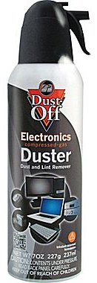
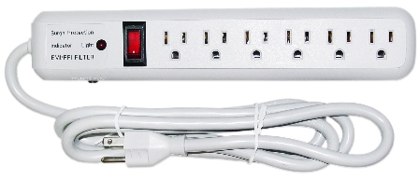
Laptop Protection
- Cooling pads can extend the life of your laptop
- Use laptops on a hard level surface with good airflow
- Purchase a laptop bag or cover if traveling
Hardware Maintenance
- Turn off and unplug your computer/laptop before cleaning
- Use canned air sprays to keep computer components dust free
- Keep monitors clean using a microfiber dust cloth and screen cleaner
- Homemade screen cleaner = 1 part 70% isopropyl alcohol and 1 part water
- Keep your computer in a cool, and dry location with good airflow

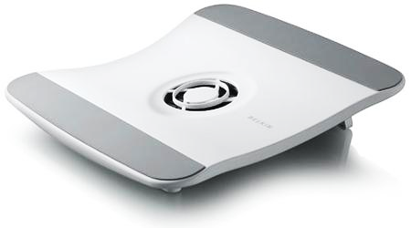

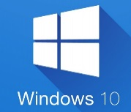
Software
- The current version of Windows is 10
- Windows XP is no long supported with security updates
  - Consider upgrading if your operating system is outdated
- Be sure to set your programs to auto update or manually update them regularly
- The best Internet browsers for security and speed include Firefox, Chrome and Opera

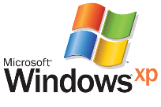





Firefox
Chrome
Opera
Edge

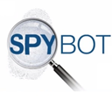

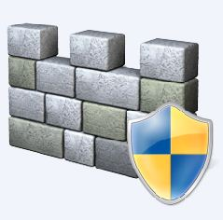
Viruses, Malware, & Spyware
- Keep yourself safe by installing and using anti-virus, anti-malware, and anti-spyware tools:
  - Windows Defender (in your computer’s Control Panel)
  - Malware Bytes (www.malwarebytes.com)
  - Spybot (www.safer-networking.org)
- Avoid clicking on ads or downloading email attachments unless you know who sent them or have scanned them with an anti-virus tool
- Back up your files to a flash drive, portable hard drive or cloud storage system regularly

Malware Bytes
Windows Defender
Spybot


Performance & Reliability
- CCleaner keeps your pc secure and running at optimum levels (www.piriform.com/ccleaner)
- Defrag your computer on a regular basis to keep it running smoothly
  - Start > System Tools > Disk Defragmenter
  - Defragging is unnecessary for solid state hard drives
- Keep an eye out on for programs running in the background by using Task Manager

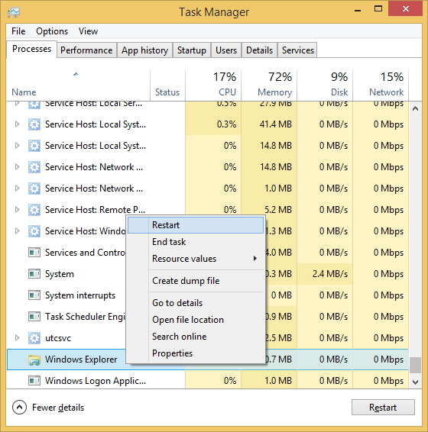

Recommendations
- Scout www.newegg.com for equipment and hardware purchases
- Purchase authorized software directly from the vendor website or retail store

