
Computer Basics

TERMINOLOGY
Computer An electronic device for storing and processing data
Desktop The primary display area of a computer screen
Desktop Computer A computer with a separate monitor, keyboard, and processor
Flash Drive A pocket-size data storage device used to save electronic files
Icon A small graphical representation of a computer program
Laptop Computer A computer that contains the monitor, processor, & keyboard in one unit
Monitor A computer component that allows users to view images
Start Menu The central launching point for programs and tasks in a Windows computer
System Tray A stationary taskbar that contains icons for system functions
Taskbar A stationary strip of icons used to access frequently used programs
Window An area of the screen that displays information for a specific program
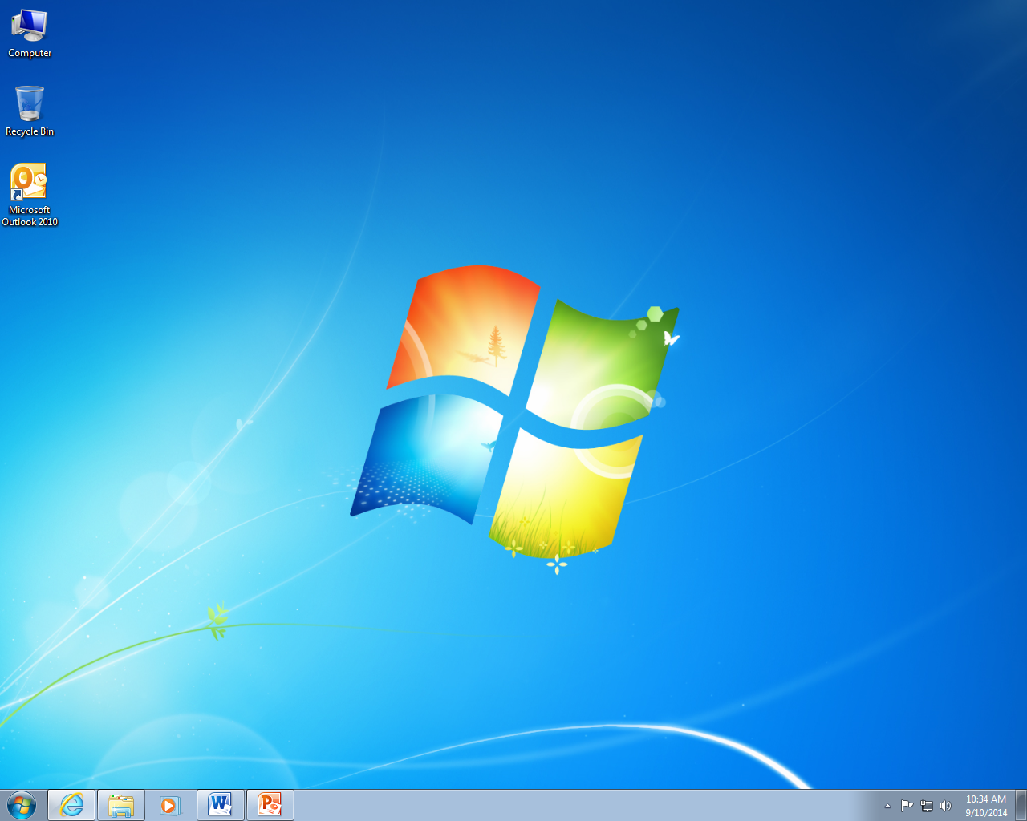
Icons

Desktop
Taskbar

System Tray

Start Menu

HOW TO CREATE, SAVE AND ACCESS FILES – In a program such as Microsoft Word, you can create files, save them and open them later for review or editing.
- Open Microsoft Word and type in your text.
- Click File > Save As
- In the new window, double-click Computer
- Select the location where you would like to save your file (ex: Desktop)
- In the File Name box, enter a title for your document
- Click Save and close the program

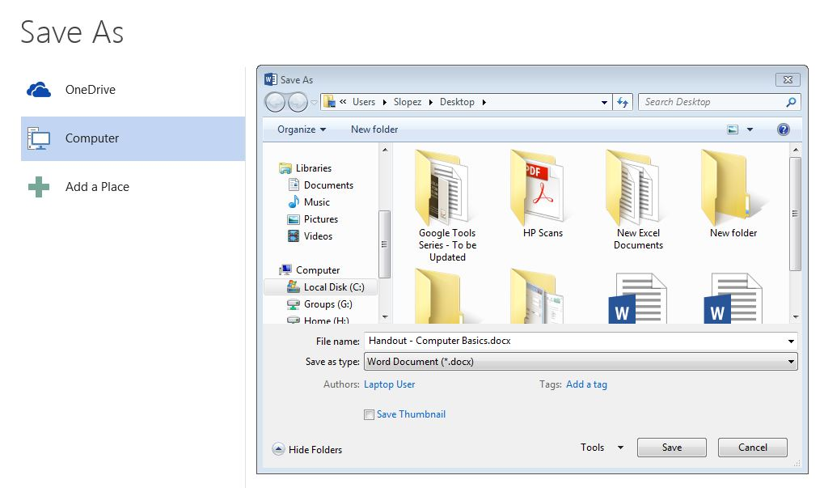
To re-open your document at any time, double-click the icon
To move the file, single-click and hold the icon, then drag it to the destination (ex: a folder on the desktop)

HOW TO CREATE A FOLDER – A folder can be created anywhere you want to store files. Some folders are pre-created for you, such as “Documents.”
- Right-click where you would like to create a folder (ex: Desktop)
- Move the cursor down to New
- Move the cursor over and click Folder
- Type in the name and press the Enter key
HOW TO RENAME A FOLDER OR FILE
- Right-click on the folder
- Click on Rename
- Type the new name and press the Enter key



