
Learner Activity Sheet:
Computer Basics (Windows 10)

ACTIVITY #1: Working from the Desktop
Use the computer desktop to answer the following questions.
If you don’t have your own computer, follow along with the instructor.
1. Name three ways in which you can open an application like Microsoft Word or the Edge browser.
a.
b.
c.
2. If you want to search for a file on your computer, where would you enter your search term?
________________________________________________________________________________________________
3. Where would you click to shut down the computer? ______________________________________
ACTIVITY #2: Working with Files
Use the computer desktop to answer the following questions.
If you don’t have your own computer, follow along with the instructor.
- Open the web browser and keep it open.
- Make the browser window wider. Move the browser window to the right side of the screen.
- What button do you click on to expand or maximize the window to fill the desktop?
___________________________________________________________________________________________
- What button do you click on to make the window smaller again? ______________________
- Use search to see if the computer has a calculator. Is there one? _______________________
- How do you see all of the windows open at one time? _________________________________
- In the web browser address bar, go to https://www.digitallearn.org/. Scroll to the bottom of the webpage.
- Name one of the links under the Learn More section at the bottom of the page.
_____________________________________________________________________________

ACTIVITY #3: Saving a File
Use the computer desktop to answer the following questions.
If you don’t have your own computer, follow along with the instructor.
- Open Microsoft Word.
- Type “Hello World” in the document.
- Save the document to the Desktop. In the File name box, type “Hello” and click Save.
- Close the file.

ACTIVITY #4: Deleting Files
Use the computer desktop to answer the following questions.
If you don’t have your own computer, follow along with the instructor.
- Move the file named Hello.docx on the Desktop to the Recycle Bin.
- Empty the Recycle Bin using one of the two methods we learned today.
ACTIVITY #5: Practice – Windows 10
Complete the Course Review lesson for Using a PC (Windows 10). You can either open a web browser and complete the activity on your own or follow along with the instructor. To complete the activity on your own:
- In the address bar of the web browser, enter www.digitallearn.org.
- Click on Using a PC (Windows 10).
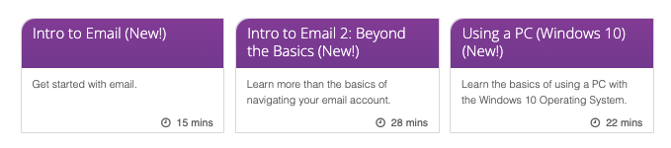
- Scroll down and click on the Practice lesson.


