
Computer Basics (Windows 10) Learner Handout
Recycle Bin
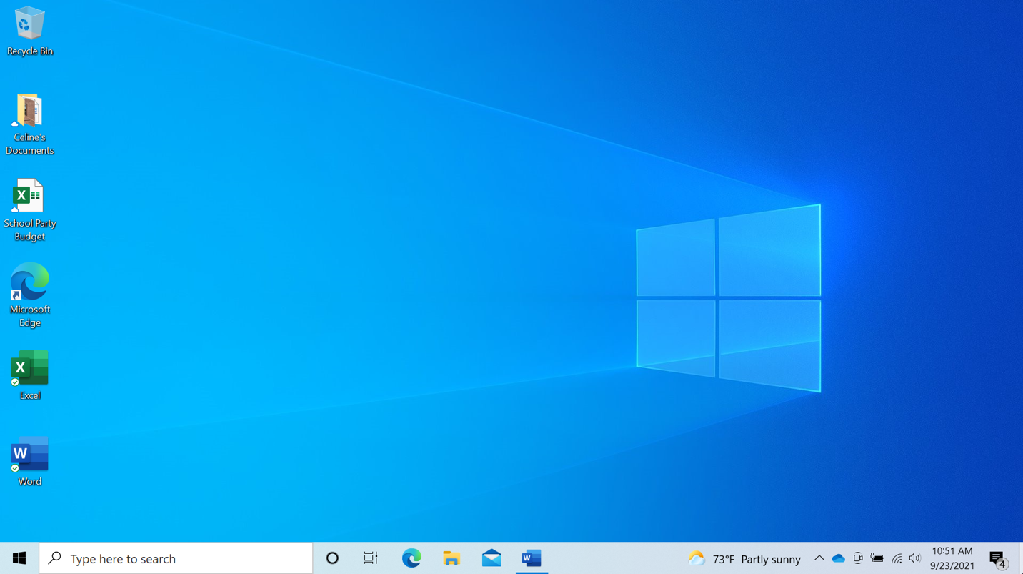
Application
Task View
Search Box
File
Folder
Desktop

Start
Menu
Taskbar
Desktop Terminology
Account: From this menu you can sign out, lock or change settings that are unique to your account on the computer.
Applications: Tools that allow you to do things on a computer, such as write a letter using Microsoft Word, search the internet using the Edge browser, and do math using a calculator.
Desktop: The area that allows you to access the applications, files, and settings.
File: A package of information.
Folder: A method for storing and organizing files.
Power: In the Start Menu, it is where you restart, shut down, or put the computer to sleep.
Recycle Bin: Holds documents here until you empty them.
Taskbar: Access the Start Menu, search, find frequently accessed applications and open files. The right-hand side of the taskbar includes notification center, date, time and volume control.
Search Box: You can search the computer for a specific file, computer setting or application.
Start Menu: Access all applications available on the computer; shut down, restart and put the computer to sleep; manage user accounts, access files and computer settings.
Task View: Displays all the windows that are currently open on the computer.
Minimize
Title Bar
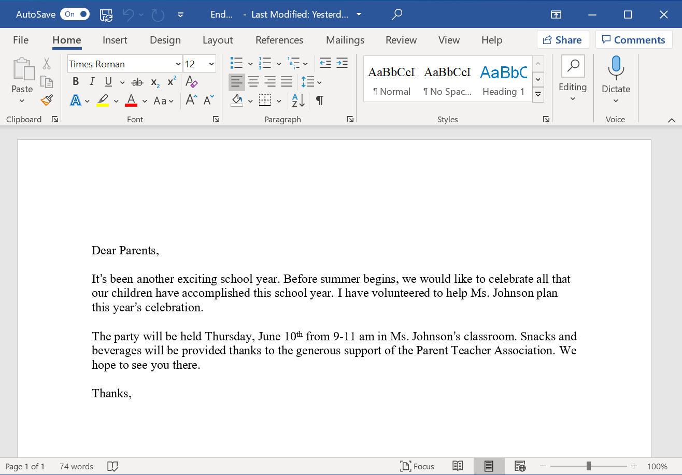
Close
Maximize
Save

Close Button: Closes the application or file.
Maximize Button: Expand the window to fill the desktop.
Minimize Button: Hides the file in the taskbar.
Restore Button: Returns the window to the size it was before it was maximized.
Scroll: Use this tool to see more of the file contents that is not visible on the current screen.
Title Bar: At the top of every window it includes the name of the software, name of the file, and includes the minimize, maximize, restore and close buttons.
Save: Use this feature so you have a copy you can view or edit later.
Window: Working area of an application.
Resize – When a window is too big or too small you can change the size of the window.
- Place the cursor on the edge of the window.
- When the cursor becomes a double-headed arrow, click and hold the left mouse button to “grab” the edges of the window.
- Drag the mouse to the left or right to change the size of the window.
- Release the mouse button when the window is the desired size.
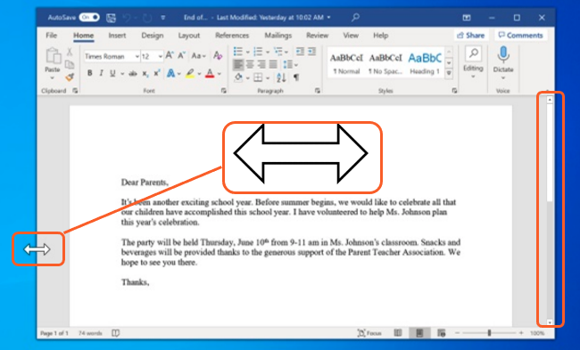
Window

Tips for Using a PC
- Desktop and Taskbar are useful tools to access common applications and documents
- Task View allows you to see all the open windows at one time.
- Folders help you organize files.
- The Search box allows you to quickly locate folders and documents.
- Documents can be restored from the Recycle Bin only if it has not been emptied.

Learn More

Visit www.digitallearn.org for more courses and to help build skills and confidence using technology.

Today’s training is provided by AT&T and the Public Library Association.

