
Learner Activity Sheet:
Computer Basics (macOS 11)

ACTIVITY #1: Working from the Desktop

Use the computer desktop if to answer the following questions.

If you don’t have your own computer, follow along with the instructor.

1. What would you click on to see what version of macOS is running on the computer?

_____________________________________________________________________________

2. Name three ways in which you can open an application like Pages or the Safari Browser.
a.
b.
c.

3. What icon would you click on to search for a file on your computer using your voice?
____________________________________________________________________________

4. Where would you click to shut down the computer? ________________________________

ACTIVITY #2: Working with Files

Use the computer desktop to answer the following questions.

If you don’t have your own computer, follow along with the instructor.

- Open the web browser and keep open.
- Make the browser window wider. Move the browser window to the right side of the screen.

- What button do you click on to expand or maximize the window to fill the desktop?
___________________________________________________________________________________
- What button do you click on to make the window smaller again? ______________
- Use the search feature to see if the computer has a calculator. Is there a
calculator?_____________
- In the web browser address bar, go to https://www.digitallearn.org/ and then scroll to the bottom of the webpage.
- Name one of the links under the Learn More section at the bottom of the webpage.
____________________________________________________________________________

ACTIVITY #3: Saving a File

Use the computer desktop to answer the following questions.

If you don’t have your own computer, follow along with the instructor.

- Open Pages.
- Type “Hello World” in the document.
- Save the document to the Desktop. In the File name box type “Hello” and click Save.
- Close the file.

ACTIVITY #4: Deleting Files

Use the computer desktop to answer the following questions.

If you don’t have your own computer, follow along with the instructor.

- Move the file named Hello.docx on the Desktop to the Trash.
- Empty the Trash.

ACTIVITY #5: Practice with macOS 11
Complete the Course Review lesson for Using macOS 11. You can either open a web browser and complete the activity on your own or follow along with the instructor. To complete the activity on your own:
- In the address bar of the web browser, enter https://www.digitallearn.org.
- Click on Using a Mac (OS 11).
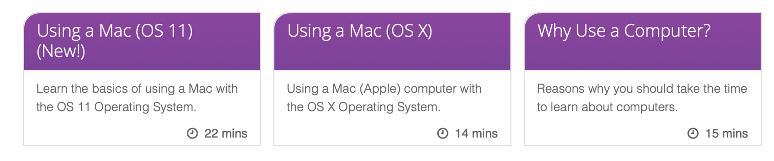

3. Scroll down and click on the Practice lesson.


