
Computer Basics (macOS 11)
Learner Handout

 Apple Menu
 Search
 Siri
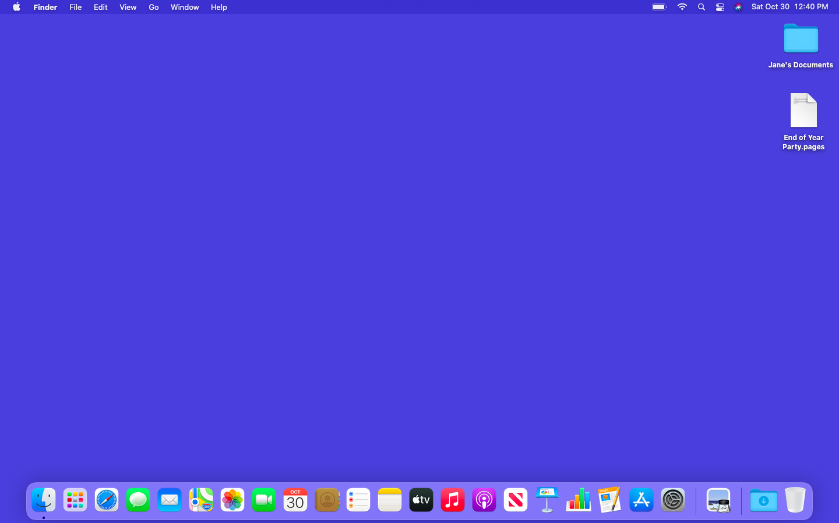
Folder

File
Menu Bar

Desktop

Launchpad
Applications
Trash

Dock
Desktop Terminology
Apple Menu: From this menu, you can access System Preferences and recently used apps. You can also view information about the computer, sign out, and lock or change settings unique to your account.

Menu Bar: Includes the Apple Menu, the date, time, volume control, and more. Menus change depending on which program is open.

Siri: A virtual assistant that responds to voice commands by using the computer speakers.

Search: You can search the computer for a specific file, computer setting, or application.
Desktop: The area that allows you to access the applications, files, and settings.

Folder: A method for storing and organizing files.

File: A package of information.

Dock: Find frequently accessed applications, open files, and empty the Trash.

Launchpad: Lists all applications available on this computer.

Applications: Tools that allow you to do things on a computer, such as write a letter using Microsoft Word, search the internet using the Safari browser, and do math using a calculator.

Trash: Holds documents until you empty them.

Title Bar
File Name
Application Open Name

Save

Title Bar: You can find this at the top of every window. It includes the name of the application that’s open and the name of the file. It also includes the Minimize, Maximize, Restore, and Close buttons.

Save: Use this feature so you have a copy that you can view or edit later.

Close Button: Closes the application or file (red circle).

Maximize Button: Expands the window to fill the desktop (green circle).

Minimize Button: Hides the file in the Taskbar (gray circle).

Restore Button: Returns the window to the size it was before it was maximized (also the green circle).

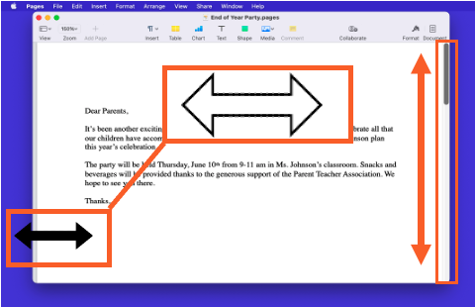
Resize: When a window is too big or too small, you can change the size of the window.
- Place the cursor on the edge of the window.
- When the cursor becomes a double-headed arrow, click and hold the left mouse button to “grab” the edges of the window.
- Drag the mouse to the left or right to change the size of the window.
- Release the mouse button when the window is the desired size.
Scroll
Window

Scroll: Use this tool to see more of the file contents that is not visible on the current screen.

Window: Working area of an application.

Tips for Using a Mac
- The Desktop and Dock are useful tools to access common applications and documents.
- Folders help you organize files.
- The Search box allows you to quickly locate folders and documents.
- Documents can be restored from the Trash only if nobody has emptied it.

Learn More
Visit https://www.digitallearn.org for more courses and to help build skills and confidence using technology.

Today’s training is provided by AT&T and the Public Library Association.

