
Coding: CSS Basics
External vs. Internal Style Sheets

Internal
Internal references are best suited for a single HTML page. This is achieved by using the <style> element on the page.
If you begin adding pages, managing the styles of each page becomes cumbersome.

External
An external reference is best for web sites containing multiple pages. All your web pages can share the same style sheet. This is achieved by using the same <link> element on each HTML page of your site for linking to a single CSS document.
It also means you can change the styles used across all pages by altering just one file.

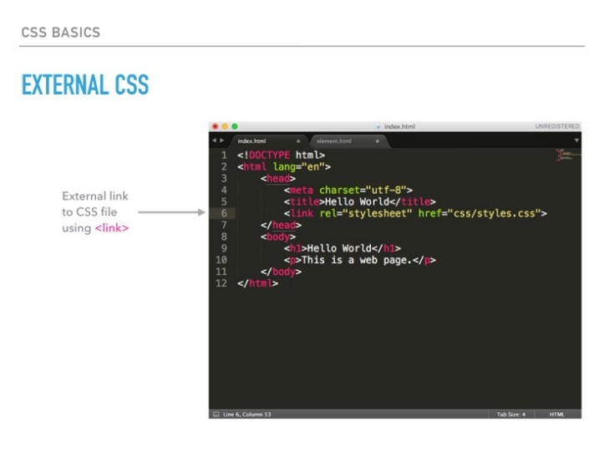
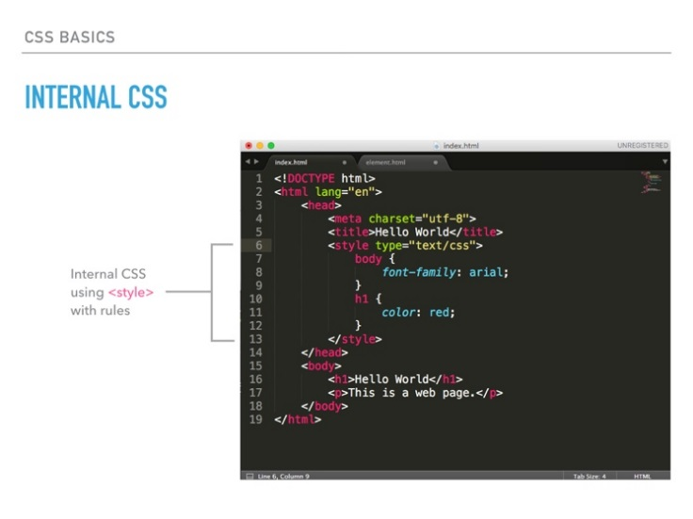

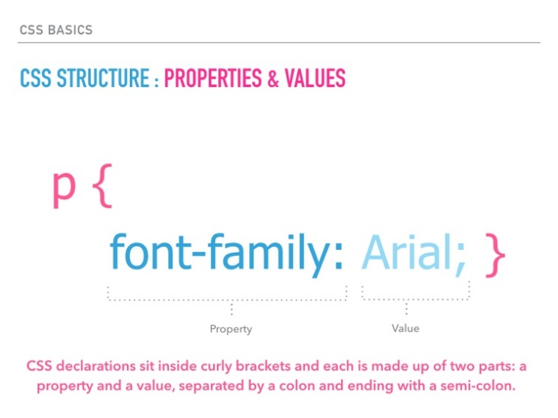
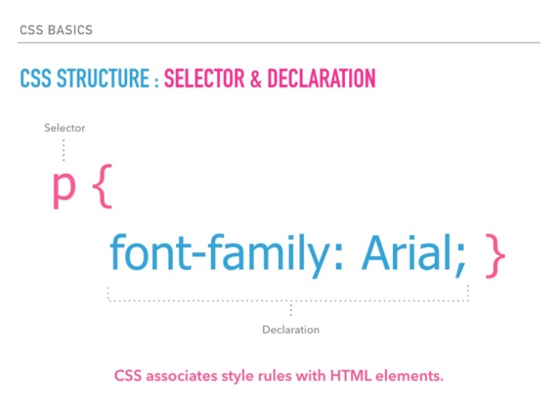

CSS selectors reference source: https://www.sitepoint.com/web-foundations/css-selectors/
CSS properties source: https://www.w3schools.com/cssref/
List of hexadecimal colors: https://www.w3schools.com/colors/colors_names.asp

