
Activity Sheet: Coding – CSS Basics

ACTIVITY #1 – Match Terminology & Descriptions
Match the following terms to their definitions.

CSS specify the settings you want to use for the chosen properties

Selectors indicate the aspects of the element you want to change

Declarations indicate how the elements referred to in the selector should be styled

Properties indicate which element a rule will be applied to

Values (Cascading Style Sheets) a language for describing the presentation of Web pages

Type Selectors allows property values to be applied to an element’s children

Class Selectors a top to bottom list of styles, the last written style takes precedence

ID Selectors Matches an element whose class attribute has a value that matches the one specified
after the period symbol

Cascade Matches element names

Inheritance Matches an element whose id attribute has a value that matches the one specified after a hash symbol

ACTIVITY #2 – How to add a header element, background color and background image
Begin by entering Codepen.io in your web browser then enter your user name and password:
- Click on your avatar to open the dropdown menu
- Click on Pens under Your Profile
- Choose Project_dotCSS to open the pen you created in the first class
- Wrap the <header> tag around the image link (logo), the nav element and the first 3 lines of text
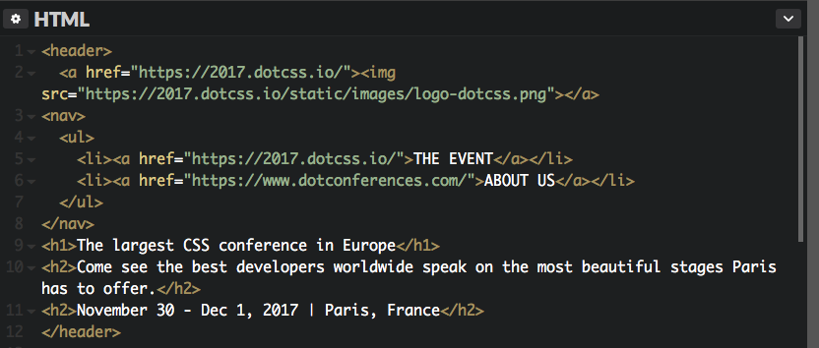
- Add the following text to your CSS panel
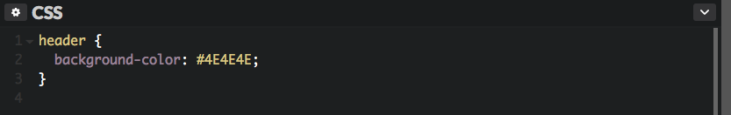

- After the background-color property, add the height, background and background-size properties to include a background image
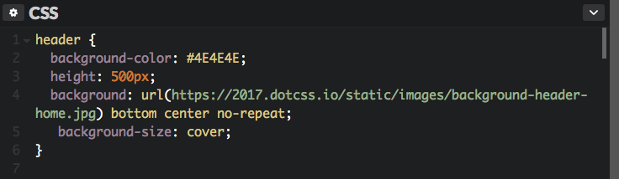

ACTIVITY #3 – How to fork a pen in Codepen
Follow these steps to fork a pen from the instructor’s collection.
- Click the magnify glass icon next to your avatar
- Notice the flashing text prompt at the beginning of the word “Search”
- Check mark the circle next to Users
- Type Meggen in the search box
- Click on the user profile titled Meggen
- Find Project_dotCSS_2.1, click on it to open it
- Click the Fork button at the top
ACTIVITY #4 – How to adjust the size of the logo
Follow these steps to adjust the size of the logo with CSS
- Add the following text class=”logo-header” between <a and href in your HTML panel
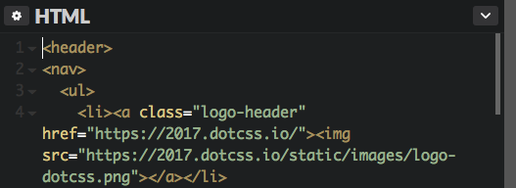
- Add the following text to your CSS panel
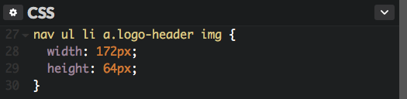

ACTIVITY #5 True or False
Choose True or False for the following statements about CSS:
True False
- □  □ A cascade is the downward order of rules with a style sheet.
- □  □ If two selectors are identical, the latter will take precedence.
- □  □ A more specified rule will take precedence over more general ones.
- □  □ Child elements inherit values from a parent element.

