
Coding: HTML Basics

Logging into your new Codepen account.

Step 1  Type Codepen.io in your browser. Then click Log In located in the upper right corner.  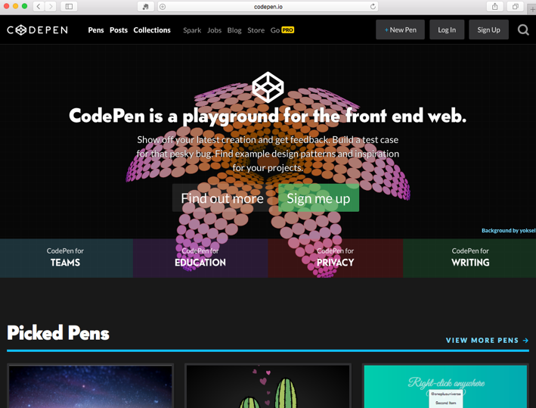 | Step 2  Enter in your Username or Email and Password then click on the green Log In button.  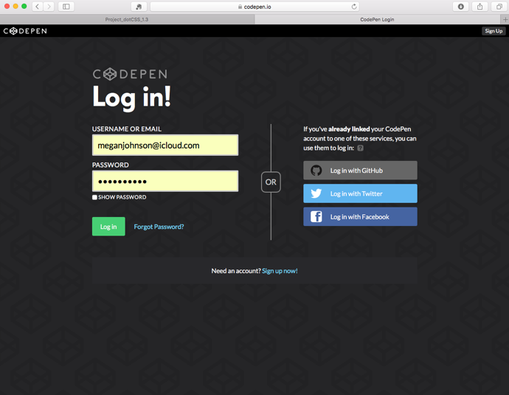
Step 3  Click on the avatar icon to open the dropdown menu.   | Step 4  Choose Pens under the title Your Profile.  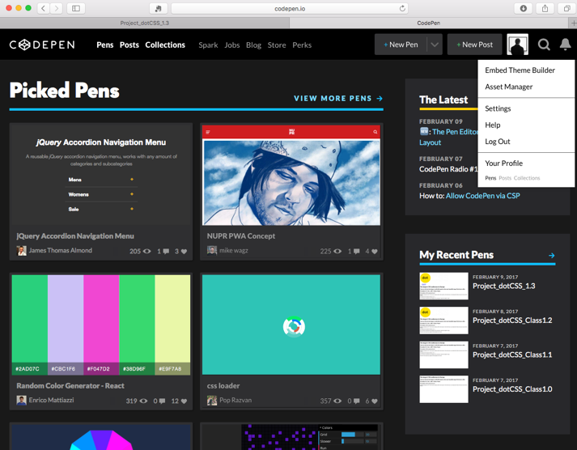

HTML Samples
Typical HTML document structure.  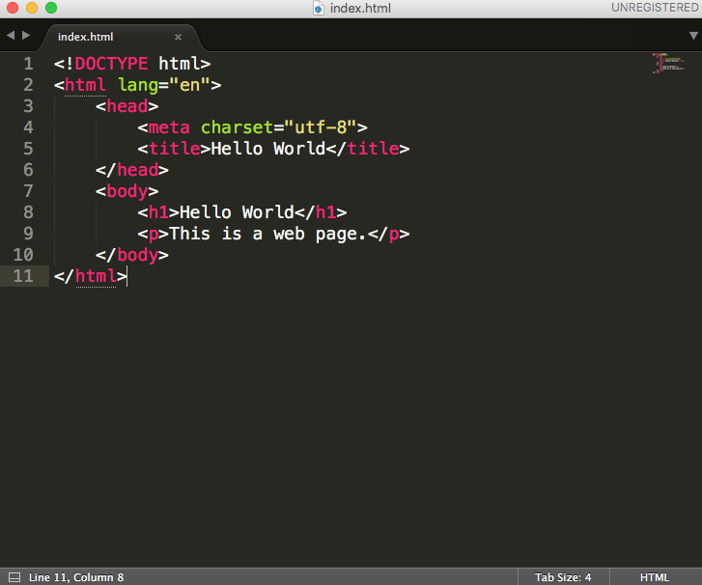 | HTML syntax with an element, attribute and tag.  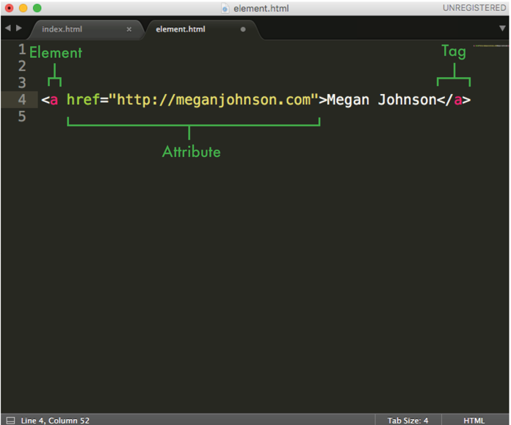

How to fork a pen in Codepen
Forking a pen allows you to place a copy of that pen within your Codepen account. You may edit the pen copy. Changes to your copy will not affect the original pen.

- Click the magnify glass icon next to your avatar
- Notice the flashing text prompt at the beginning of the word “Search”
- Check mark the circle next to Users
- Type Meggen in the search box
- Click on the user profile titled Meggen
- Choose any pen, click on it to open it
- Click the Fork button at the top

You now have a copy of the pen in your personal account.

List of free Text Editors
You can download any of the editors listed below from the web.
- Sublime (Mac/ Windows)
- Notepad++ (Windows)
- TextWrangler (Mac)

HTML element reference source: https://developer.mozilla.org/en-US/docs/Web/HTML/Element

