
Activity Sheet: Coding – HTML Basics

ACTIVITY #1 – Match Terminology & Descriptions
Match the following terms to their definitions.

HTML are designators that define the structure and content within a page

Text Editor a set of less-than and greater-than symbols that surround an element

Web Browser provide additional information about an element which include a name and a value

Codepen an element that begins a new line, stacking one on top of the other

Elements an element that falls within the normal flow of a document

Tags (HyperText Markup Language) gives content structure and meaning

Attributes a type of program used for editing plain text files

Block-level Element an application for locating, retrieving and displaying content

Inline Element is an in-browser code editor for writing HTML and CSS with a real-time preview

ACTIVITY #2 – Setting up a Codepen account (An email address is required.)
Begin by entering Codepen.io in your web browser then follow these steps to set up your account:
- Click on the green Sign me up button
- Scroll down to the Free Plan option and click on the Sign Up button
- Fill out the form and click on the box next to “I’m not a robot”

Note: Check your email inbox for a verification message from Codepen and complete the setup of your account within the next 24 hours. You will be logging into your account for the next two class sessions.

ACTIVITY #3 – Creating an HTML document in Codepen
Follow these steps to create an HTML document.
- Click on the pencil icon near the upper left corner
- Enter the title Project_dotCSS
- Enter the following text into the HTML box

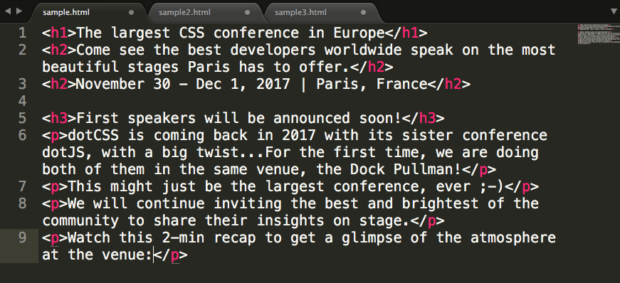

- Click on the Save button at the top

ACTIVITY #4 – How to add an element with an attribute.
Follow these steps to add an anchor element:
- Enter the following text to the top of the HTML document
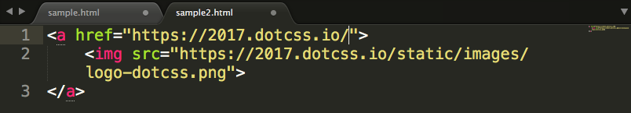

- Click on the Save button at the top

ACTIVITY #5 – How to add block-level nav element
Follow these steps to add a navigational element:

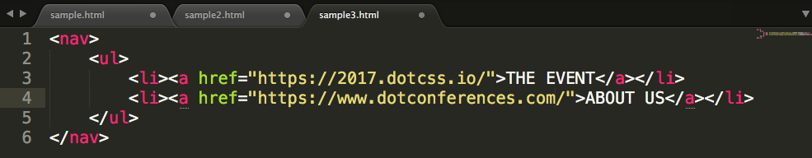
- Enter the following text just below the anchor element in the HTML document

- Click on the Save button at the top
Bonus – Follow these steps to add an inline element:
- Locate “dotCSS” at the beginning of the first paragraph
- Enter the tag <strong> between <p> and dotCSS
- Enter the tag </strong> after dotCSS
- Click the Save button and view the change in the preview window

