
Coding: CSS Beyond Basics
The Box Model
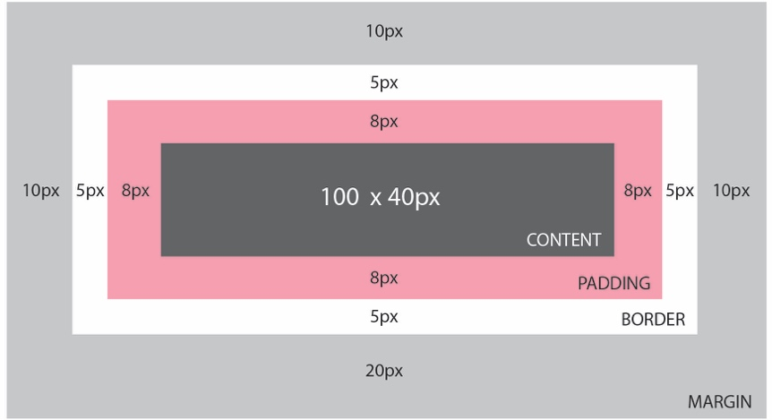

Finding the Developer Tool in the Google Chrome Browser

- Begin by downloading Google Chrome onto your computer if you don’t already have it installed
- With any site open, click on View located in top menu
- Choose Developer from the dropdown menu
- Choose Developer Tools from the second dropdown menu

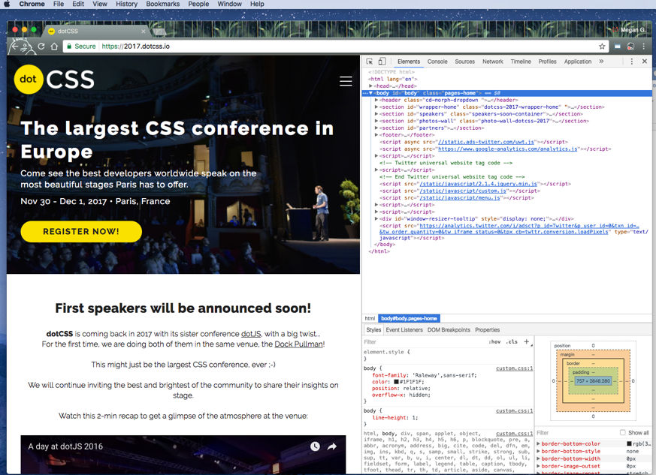

Book List for further learning:
- HTML & CSS Design and Build Websites by Jon Duckett
- Learn to Code HTML & CSS Develop & Style Websites by Shay Howe
- HTML: The Missing Manual by Matthew MacDonald
- CSS: The Missing Manual by David Sawyer McFarland
- Beginning HTML5 & CSS3 for Dummies by Ed Tittel and Chris Minnick

Font Resources for Google:
Google Fonts source: https://fonts.google.com/
Previewing source for Google Fonts: http://typecast.com/preview/google

