
Activity Sheet: CSS Beyond Basics

ACTIVITY #1 – Match Terminology & Descriptions
Match the following terms to their definitions.

Semantic Elements defines elements as a rectangular box with height, padding, borders & margins

Header sits outside the edge of a border

Nav the space between the border of a box and its content

Section separates the edge of one box from another

Article a file of a typeface hosted on a server

Aside HTML elements with specific meaning for defining the content

Footer an element specifying a header for a document or section

Box Model an element defining a set of navigational links

Margin an element defining a section in a document

Padding an element for specifying independent or self-contained content

Border an element defining content aside from the surrounding content (like a sidebar)

Web Font an element for specifying the footer of a document or section

ACTIVITY #2 – Further practice on forking pens in Codepen
Follow these steps to fork a pen from the instructor’s collection.

- Click the magnify glass icon next to your avatar
- Notice the flashing text prompt at the beginning of the word “Search”
- Check mark the circle next to Users
- Type Meggen in the search box
- Click on the user profile titled Meggen
- Find Project_dotCSS_3.0, click on it to open it
- Click the Fork button at the top

ACTIVITY #3 – How to add style to the text
Follow these steps to style the text on your web page:
  - Add the following text to the top of your CSS panel
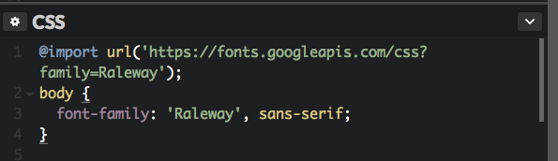
  - Starting on line 44 add the following text to your CSS panel
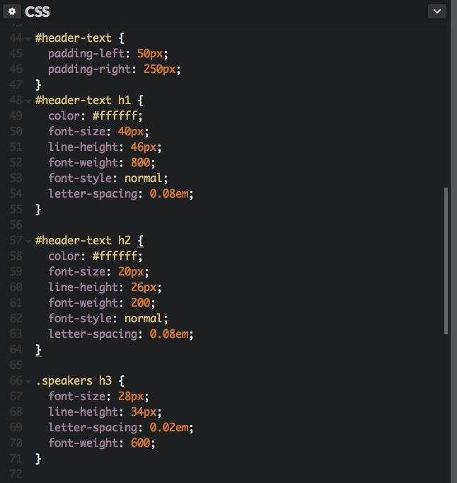

ACTIVITY #4 – The Box Model
Label the areas of the Box Model with the correct terms.
Terms: Content Padding Border Margin
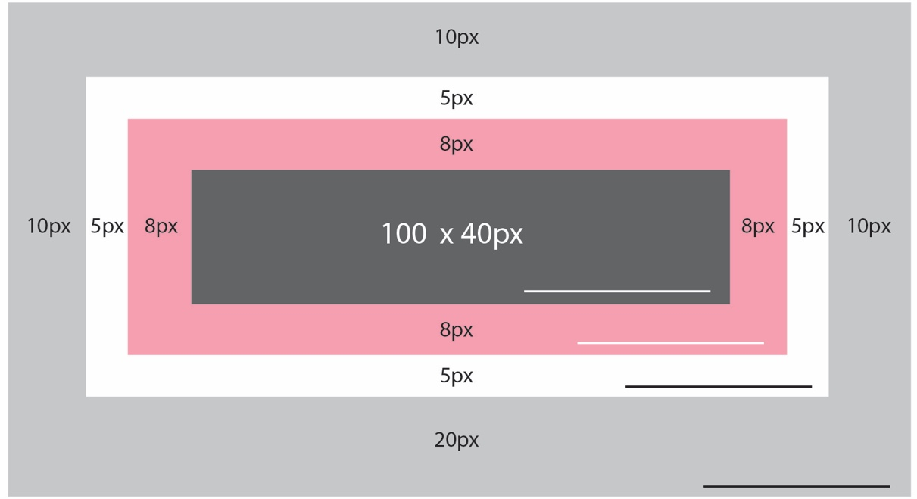

Bonus: Calculate the total height and width of the box above.

Height Width

ACTIVITY #5 How to center content on a fix-width web page
Follow these steps to center text and video on your web page:
- Starting on line 66 add the following text to your CSS panel


