
Handout: Canva
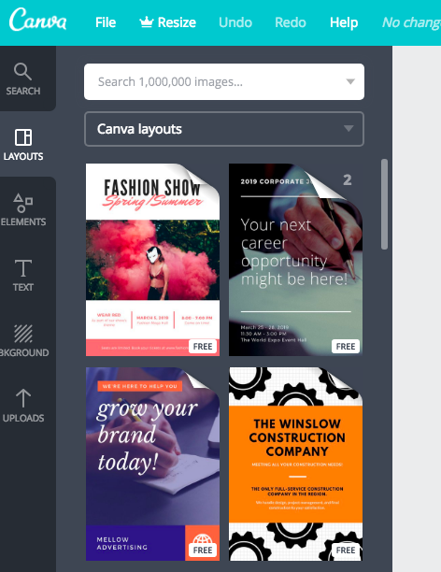
Upload your own images to Canva and add them to your design
Change the background of your design with solid and pattern options
Select a template layout from various
Add text to your design
Add shapes, illustrations, icons, lines, or other visual/graphic elements
Search for an image using keywords

Tips and Reminders
- To return to Canva’s Landing Page and see the All My Designs gallery, click on the Canva logo in the upper left hand corner of the page.
- To change the name of your file, click on the default title given the design (white text without any border/shadow around it) in the teal ribbon. A text box will drop down. Enter the name you’d like to give your design here.
- To download your design, click the “Download” button in the teal ribbon. Choose the file format you prefer (JPEG, PDF, etc) and then click the green Download button. Once you have downloaded your design, you will be able to print from the download.
Change the trans-parency of an element
Separate elements to edit indepen-dently
Change font color and format bold, italics, alignment, CAPS, and lists/bulletpoints
Spacing options
Change font and font size

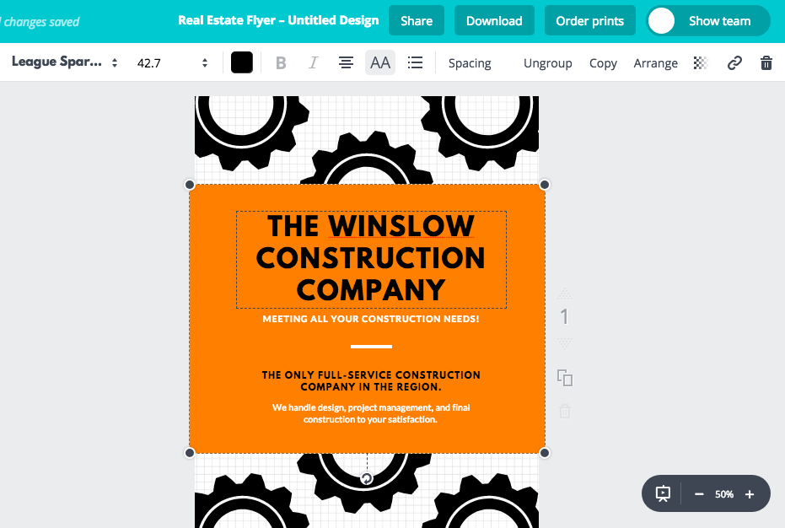

Add a link and delete elements
Send elements of your design forward or back
Copy an element to paste elsewhere

Text/Highlight Box & Images
Used to highlight a particular area in an image or to include text next to an image
Click on any text to open the text formatting toolbar

Zoom in and out

ALWAYS put images In front of text so you can move them freely throughout your document
Images should have a border (Black, 1 ½pt outline)

