Best Travel Apps

**Using Apps & the Internet on the Go**

* **Connect to Wi-Fi when you can** – Free networks are often available at libraries, coffee shops, hotels, etc.
* **Use Cellular Data if Wi-Fi is not available** – Depending on your mobile plan (Verizon, AT&T, Sprint, etc.), you may have a data limit. Make sure to close apps when not in use.



**What Does Location Services Do?**

* Built-in feature for smartphones/tablets that provides apps with real-time coordinates and allows for mapping, GPS navigation, destination searching and more.
* Must be enabled in order for apps to work properly



**Enabling Location Services**

**Android**

1. Slide down your Notifications screen
2. Tap the Location icon to enable Location Services

**iOS**

1. Tap Settings
2. Tap Privacy
3. Tap Location Services
4. Tap the toggle button to enable Location Services

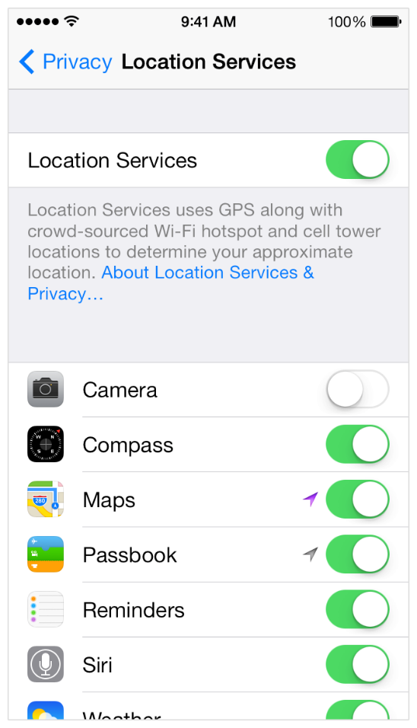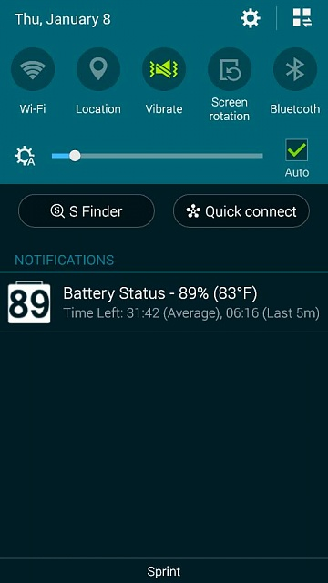

**Where to Find & Download Travel Apps**

**Google Play Apple Store Amazon Apps**

(Android) (iOS) (Kindle)

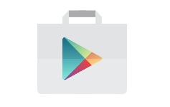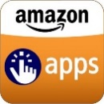

On the back of this page, you’ll find a list of popular travel related apps including the ones covered in class. Explore your app store to find more!

**Planning Your Adventure**

Marriott

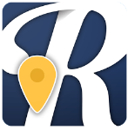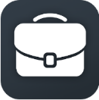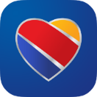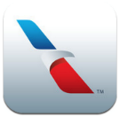

Roadtrippers

Tripcase

Priceline

TripAdvisor

Expedia

Hopper

Southwest Airlines

American Airlines

AirBnB



**Things to Do**

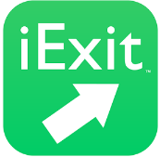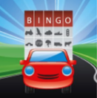

GasBuddy



Speedway

iExit

Roadtrip Games

Waze

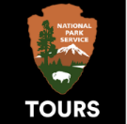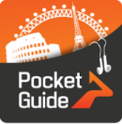

Time Out

National Park Service

Ulmon Maps

Pocket Guide Audio

Lonely Planet Guides

**Takin’ a Roadtrip**



Uber

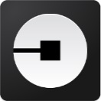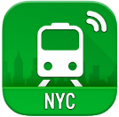

CityMapper

Moovit

Metro San Fran

MyTransit NYC

**Don’t Get Lost**

**Connecting While Away**

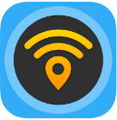

WiFi Map



Skype

Facebook

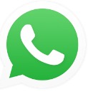

WhatsApp

International Calling



FirstAid

ZocDoc

AccuWeather



**Always Be Prepared**

**Over the Border**



Google Translate

XE Currency

Microsoft Translate