
Build Your Own Desktop PC – Part 1
Basic Computer Components
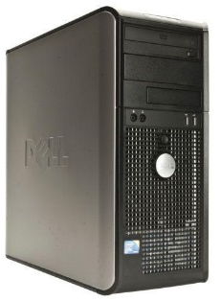
Computer Case – Houses all the computer components to form the tower
- Various sizes – typical size is a mid or full tower
- Price Range: $20 - $350

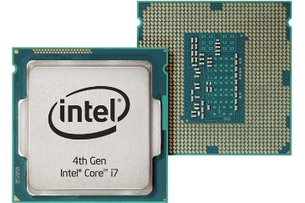
CPU/APU - The main chip that processes programs and apps
- CPU - Central Processing Unit
- APU – Accelerated Processing Unit (includes graphics)
- Use www.passmark.com to determine a component’s score

 | Light User | Moderate User | Power User
Passmark Score | APU: 3000+ | APU/CPU: 5000+ | APU/CPU: 8000+
Price Range | $55-$100 | $110-$180 | $200-$1000

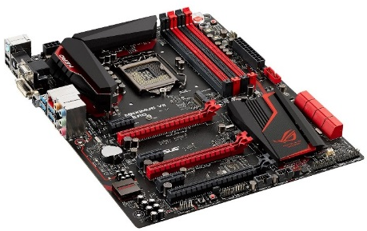
Motherboard - The mainboard that connects all your components
- Match your motherboard to your CPU (brand, socket, case)
- Consider features (Ram support, Sata slots, Video support, ports, etc.)
- Price Range: $35-$$350

GPU (Graphics Processing Unit) – Allows images to be displayed on the screen
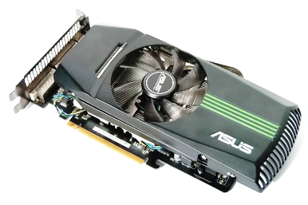
 | Light User | Moderate User | Power User
Passmark Score | APU can handle graphics | GPU: 4000+ | GPU: 7000+
Price Range | $0 | $120-$200 | $250-$1000

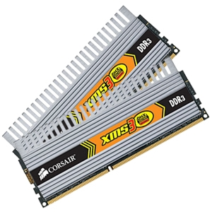
RAM (Random Access Memory) – Runs all of your programs and apps
- Size: Minimum – 4GB, Recommended – 8GB+
- Must be compatible with your motherboard
- DDR4 is the new standard, making it faster and more expensive
- Price Range: $5-$10 per GB

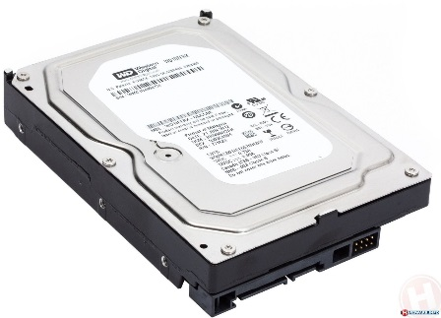
Hard Drive - Saves your files, programs, and apps to the computer
- SSD drives – Quickest
- Hybrid drives – Quick with high storage
- Mechanical hard drive – Most common, slowest w/ highest storage

 | Low Storage User (SSD) | High Storage User
Capacity | 120GB-240 GB | 500GB-2TB
Price Range | $45-$120 | $40-$150

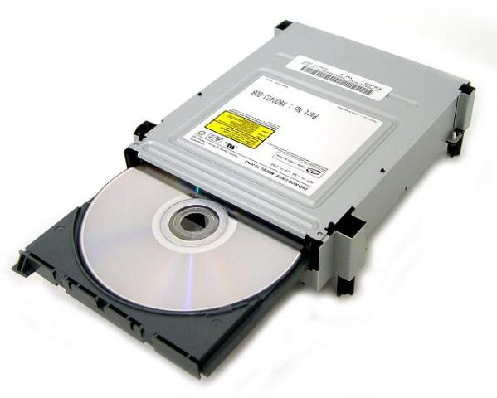
Optical Drive – For reading discs (CD, DVD, Blu-Ray)
- If you will not load media or watch videos from discs, an optical drive is not necessary
- Price Range: $20 - $200

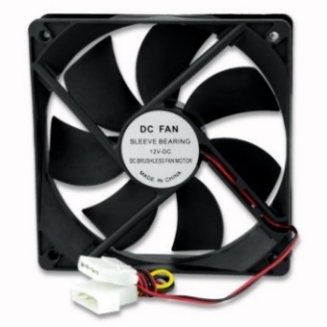
Cooling Fans - Keeps the parts cool to prevent overheating/damage
- 1 fan is typical for light user; 2+ for moderate & power users
- Quieter fans begin in the 17dB level and lower
- Common sizes: 120mm or 92mm
- Price Range: $6-$40

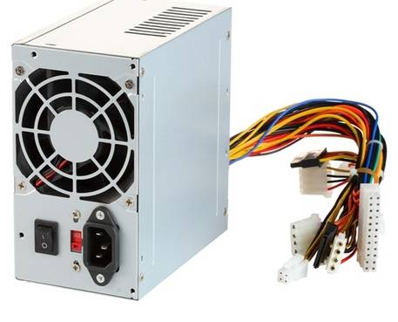
PSU (Power Supply Unit) – Powers all of your components
- Use a PSU calculator to determine wattage needs
  - http://outervision.com/power-supply-calculator
- Verify your 12-volt rail has enough Amps for your graphics card
- Price Range: $40-$200

Operating Systems
Windows
- Windows 10 is the current version
- Beware of when security updates will end for older versions (ex: Windows 7 ends in 2020)
Linux
- Free alternative to Windows but geared towards tech-savy crowd
- Umbuntu, Mint, Lumbuntu are the popular versions
Trusted Brands
Less Reliable Brands

ASUS | Adata | Patriot
Gigabyte | Western Digital | ECS Elite Group
MSI | EVGA | Biostar
Kingston | XFX | Logisys
Corsair | Zotac | Super Talent

Consider purchasing components in person at Fry’s Electronics, Micro Center or online through Newegg or Amazon

