
Activity Sheet: MS Word – Tables, Images and Graphics

ACTIVITY #1
Part 1: Practice Inserting a Table and Entering Data
- Open a blank MS Word document
- Insert a table that is three (3) rows across and three (3) columns down
- Enter the days of the week as your column headings
- Below the days of the week, enter the 2nd and 3rd rows of text as shown in the example below
- Insert a new row at the bottom of the table to accommodate the 4th row of text
Tuesday | Wednesday | Thursday
Oil Change | Make Lunch | Pay Bills
Grocery Shopping | Word Class | Clean Kitchen
Make Dinner | Gym | Read Book

Part 2: Practice Formatting a table
- Apply a design of your choice to your table from Table Styles
- Change the height of all rows to 0.25 and the width of all columns to 2.0
- Bold and Center Align the days of the week
- Select the table and drag it down a few spaces

ACTIVITY #2
Part 1: Practice Inserting an online picture
- Double-click in the open space below your table to set a new insertion point

- From the Insert Tab, click on the Online Pictures button
- Type To Do List in the Search box and hit Enter
- Select an image you like and insert it into your document

Part 2: Practice Formatting an Image
- Re-size the image so it is appropriate for the document
- Click the Wrap Text button and select Behind Text
- Reposition the image so it is in the right corner above the table
- Apply one of the Picture Styles to the image

ACTIVITY #3
Part 1: Practice Inserting WordArt
- Double-click in the open space below your table to set a new insertion point
- From the Insert Tab, click the WordArt button
Today’s Tasks
- Select one of the styles
- In the text box that appears, type Today’s Tasks

Part 2: Practice formatting WordArt
- Add a background color to the WordArt box using Shape Fill
- Add a different Shape Outline color to surround the WordArt box
- With the text selected, increase the Font Size to 48
- Click the Text Effects button from the WordArt Styles group and select on the Transform styles
- Reposition your Word Art so it is in the left corner above your table

ACTIVITY #4
Practice adding a border and watermark to your document
- From the Design tab, insert a colored, 3pt line border around your document
- Apply a Textured page background. Hint: Use the Fill Effects option in the Page Color Menu.
- Insert a Custom Text Watermark that states Things to Do
- Remove the Watermark
- Insert an artistic Horizontal line underneath your table using the Page Borders button
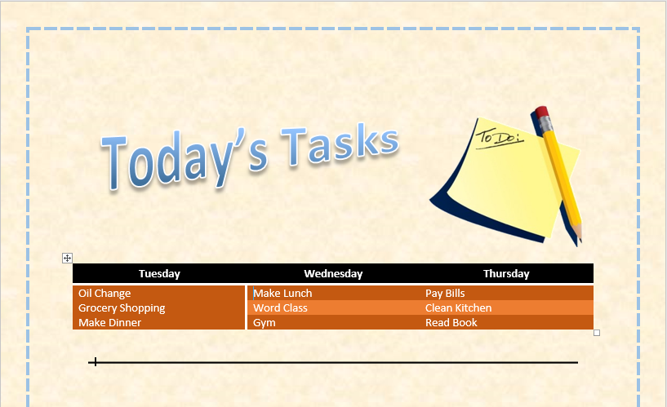

Example of completed Activity

