
Microsoft Word: Formatting Documents

THE FONT GROUP (Located on the Home tab)
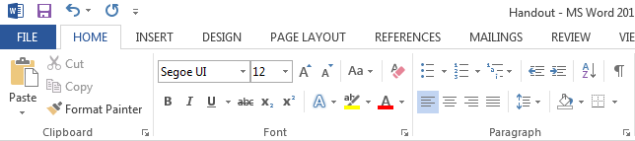

FONT FORMATTING TOOLS
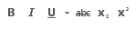
Bold, Italics, Underline, Strikethrough, Subscript, Superscript
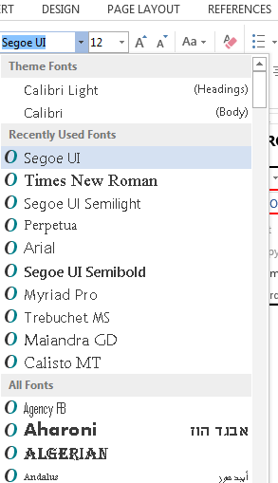
Font Style

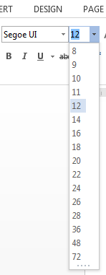
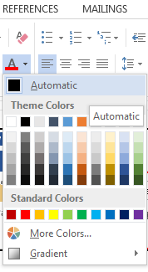
Font Size
Font Color

THE PARAGRAPH GROUP (Located on the Home tab)

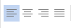
PARAGRAPH FORMATTING TOOLS
Alignment (Left, Middle, Right or Justify)
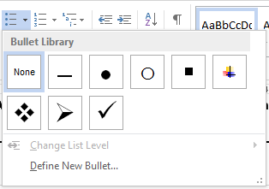
Bullet List

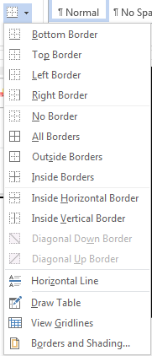
Borders & Shading

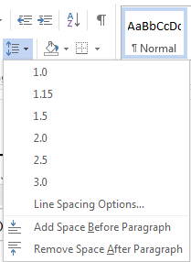
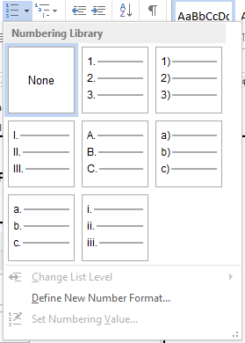
Line Spacing
Number List

