
Microsoft Word: Editing Tools
Cut: Moves an item to the Clipboard for insertion into another location or document
Copy: Places a copy of an item on the Clipboard for insertion into another location or document
Paste: Inserts an item from the Clipboard into a document

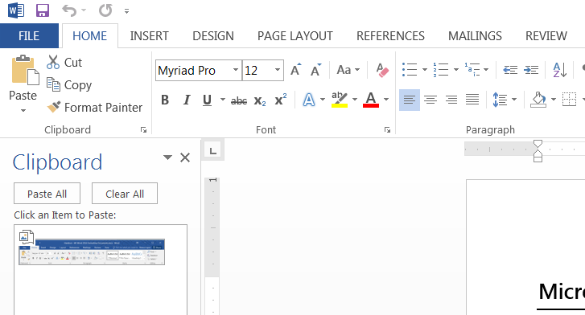
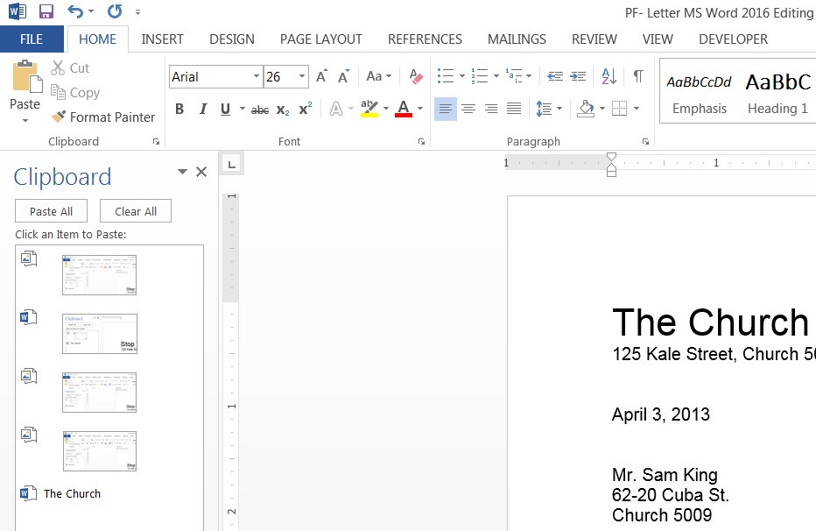
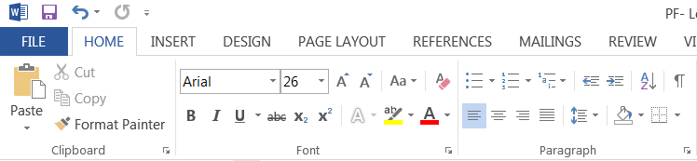
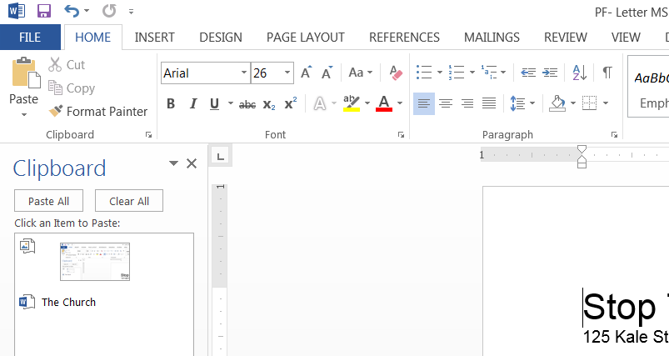

Cutting & Pasting
- On the Home Tab, click the dialog box launcher in the lower-right hand corner of the Clipboard Group
- Highlight the text/object you wish to cut and paste
- Click the Cut button in the Clipboard group
- Click the area on the document where you want to insert the item
- Click on the item in the Clipboard pane to Paste it

Copying & Pasting – Copying items follows the same steps as cutting. To Copy items, click the Copy button.

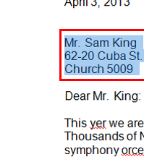
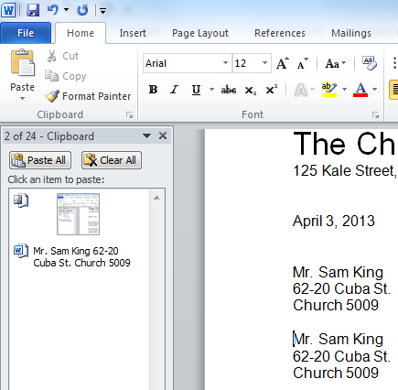
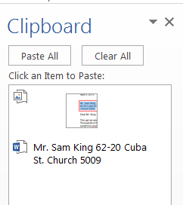

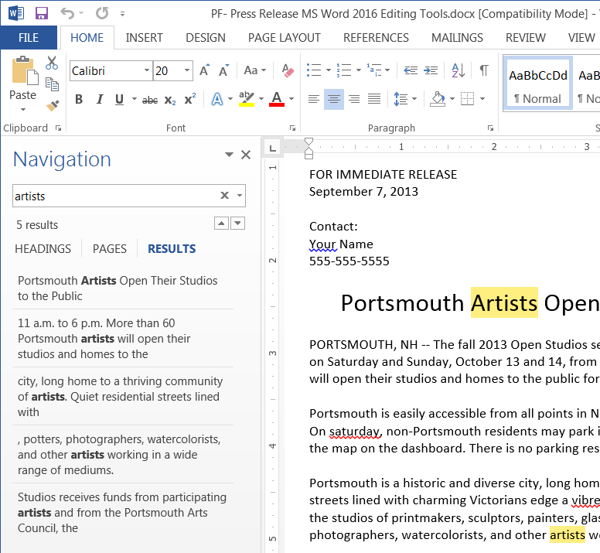
Finding Text
- From the Home Tab, click the button in the Editing Group
- In the Navigation Pane that appears on the left-hand side, type the words you are searching for. Results will auto-populate in the pane.
- Click on a result to locate it in the document
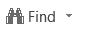

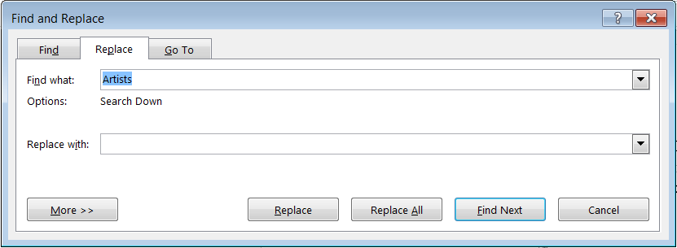
Replacing Text
- Click the Replace button
- In the Find and Replace pop-up window, enter the desired text
- Select one of the following: Replace, Replace All, or Find Next

- Replace: Replaces the first instance of the word
- Replace All: Replaces all instances of the word
- Find Next: Replaces the first instance of the and then moves to the next one for review

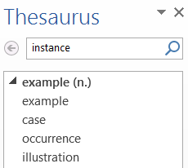
Using the Thesaurus
- Click the Review tab
- Highlight the desired word
- Click the Thesaurus button in the Proofing group
- A synonym list appears in the Thesaurus pane

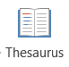

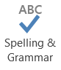
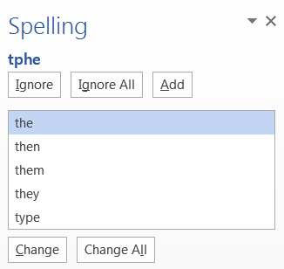
Spelling & Grammar
While typing text, Word will display spelling and grammar errors
- Red underline = spelling errors
- Blue underline = grammatical error
Word’s suggested corrections are available by clicking the Spelling & Grammar button on the Review Tab. Options for making adjustments include: Ignore Once, Ignore All, Add to Dictionary, Change All, or AutoCorrect.

