
Microsoft Word: Basics

BASIC ELEMENTS OF THE PROGRAM WINDOW
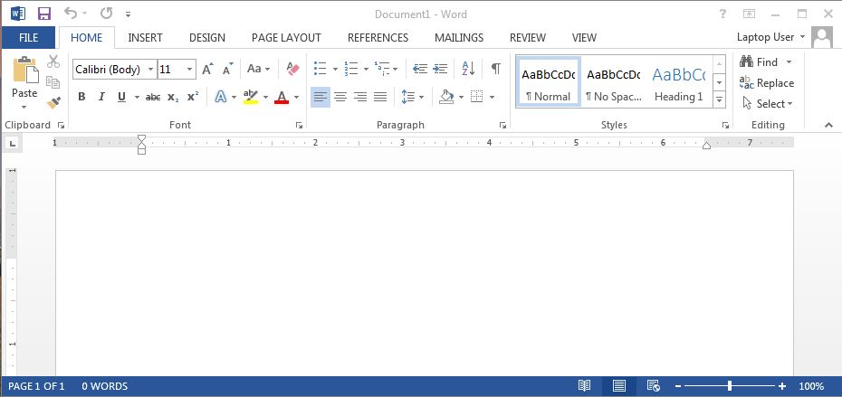
View Buttons
Zoom Slider
Quick Access Toolbar
Document Window
Horizontal & Vertical Rulers
Title Bar
Status Bar
Minimize, Maximize, Close
Scroll Bar & Arrows

THE RIBBON
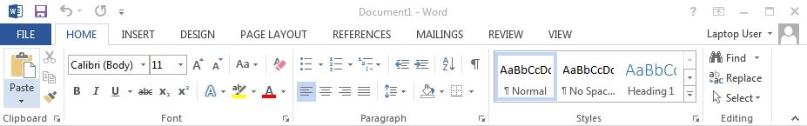
File Tab
Tabs
Groups
Launcher

Tab Groups
Home Clipboard, Font, Paragraph, Styles, & Editing
Insert Pages, Tables, Illustrations, Add-in, Media, Links, Header/Footer, Text, & Symbols
Design Themes, Document Formatting, Page Background
Page Layout Page Setup, Paragraph, & Arrange
References Table of Contents, Footnotes, Citations, Captions, Index, & Table of Authorities
Mailings Create, Start Mail Merge, Write/Insert Fields, Preview Results, & Finish
Review Proofing, Language, Comments, Tracking, Changes, Compare, & Protect
View Document Views, Show, Zoom, Window, & Macros
The exception is the File tab which includes general commands along with file options. On this tab you will find Info, New, Open, Save, Save As, Print, Share, Export, Close, Account, and Options.

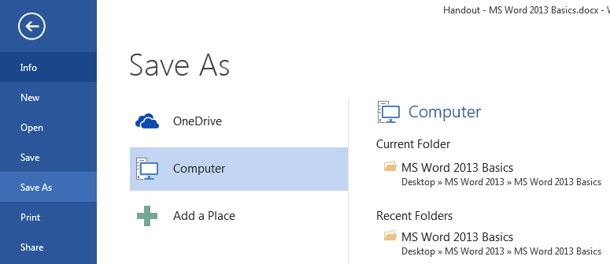
SAVE & SAVE AS

Save
SAVE AS
- Click File
- Click Save As
- Select the location
- Name the document
- Click Save

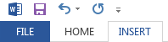

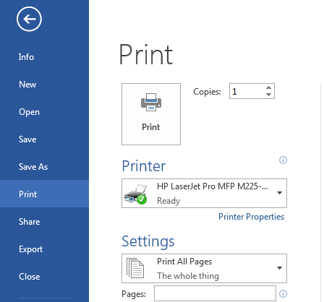
PRINTING
PRINTING
- Click File
- Click Print on the menu
- Check Printer Settings & adjust if necessary (Copies, Pages, Double-Sided, etc.)
- Click the Print button



