Microsoft Publisher 2013: Enhancing Your Docs
THE INSERT TAB

Insert Pictures from your computer, Online Pictures (Clip Art & more), or draw Shapes
Draw a Text Box

EDITING FROM THE HOME TAB
When objects are added, basic modifications can be made from the Home tab

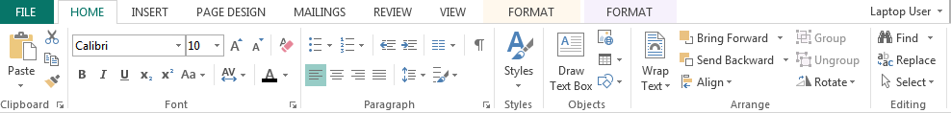
Cut, Copy & Paste
Bring Forward – Brings an object up a “layer” or to the front of another object
Send Backward – Sends an object back a “layer” or just behind another object
Rotate

Take note of the selection box around the object & the mouse cursor when modifying objects
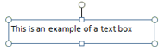
Free Rotate
Grouping Objects
Move
Resize

DRAWING TOOLS TAB
The Drawing Tools tab appears when a Text Box or Shape is selected

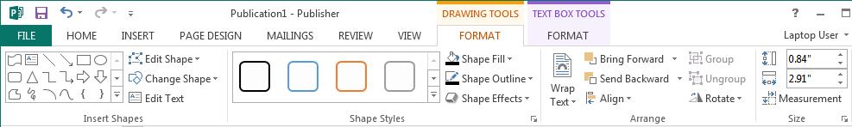
Manual Size Adjustment
Shape Style Options
Change Shape

TEXT BOX TOOLS TAB
The Text Box Tools tab appears when a Text Box is selected

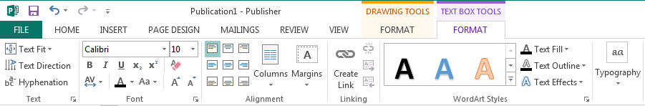
Text Direction
Text Alignment Options
WordArt Styles

PICTURE TOOLS TAB
The Picture Tools tab appears when an image is selected

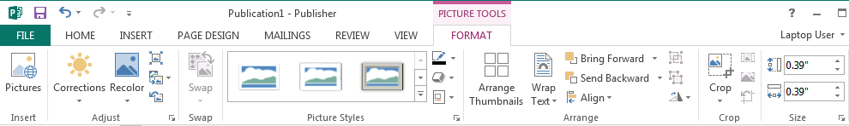
Color Adjustments
Picture Styles
Cropping Options

