Activity Sheet: MS Excel – Working with Tables

Activity #1
Practice Sorting a list by more than one level
- Open the Names List practice file
- Click on cell A2
- Click the Data tab in the Ribbon then click the Sort button
- In the Sort by box, choose Last Name from the drop down menu
- Click the Add Level button
- In the Then by box, choose First Name from the drop down menu
- Click the Ok button

Practice Filtering a list
- From the Data tab in the Ribbon, click the Filter button
- Click the down arrow on cell D1 then click the box next to Select All to uncheck it
- Click the box next to Elgin to show only Elgin residents
- Click the Ok button
- Click the Filter arrow button in the column where the filter has been applied
- In the Sort/Filter window, click on Clear Filter from “City”
Activity #2
- Click the Page Layout tab in the Ribbon then click the Print Titles button
- When the Page Setup window opens, click the Sheet tab (it may already be selected)
- Click in the Rows to repeat at top box then click on cell A1
- Click the Ok button
- Click the File tab then Print to view the document. Arrow through the pages to see that the column headings now appear on each page.
- Click the arrow at the top to return to the workbook (printing is not necessary)
Activity #3
- Click on cell A2
- Click the Insert tab in the Ribbon then click the Table button
- Verify that the data range is correct then click the Ok button
- Click on any cell in the table then click the Design tab
- Choose a different Table Style
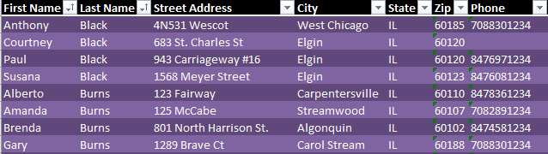

Activity #4
- Click on cell A2
- Click the Insert tab in the Ribbon then click the Pivot Table button
- Click the Ok button
- In the Pivot Table Fields options, click the boxes next to City and Last Name to select them
- Click and drag Last Name from the Row Header box to the Values Box
- Click on any cell in the Pivot Table then click on the Design tab
- Choose a different Pivot Table Style
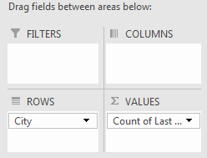
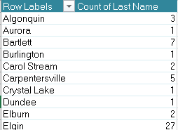

Activity #5 – Challenge activity for the end of the class (if time permits)
- Open the Vehicles workbook
- Change the page setup so row 1 will print at the top of each page. Print preview the worksheet to verify. Do not print the page.
- Add a Filter to show only Ford vehicles
- Clear the Filter
- Sort by Department
- Create a Pivot Table to match the one below
