MS Excel: Formulas & Functions

**NOTES ON FORMULAS**

* **Formula** – An expression that calculates a value. Starts with an **=**, you enter the cell addresses, operators or functions to do the calculations
* **Function** – Used in a formula, the operations needed have already been defined for you. Each function needs arguments and produces a result.

=A1+A2

* A formula is entered in the cell in which the result is to be displayed
* A formula can include numbers, cell references or ranges, and **operators** (**+ - / \***)
* If possible, avoid typing numbers into a formula. Refer to the cell/ranges with the numbers in it.

**ORDER OF OPERATIONS**

* Formulas are calculated from left to right
* Any operation in parentheses is calculated first.
* Multiplication and division are always done before any addition or subtraction.
* **P**lease **E**xcuse **M**y **D**ear **A**unt **S**ally to remember **P**arentheses, **E**xponents (not covered in this class), **M**ultiplication, **D**ivision, **A**ddition, and **S**ubtraction

**QUICK ACCESS TO COMMON FUNCTIONS**

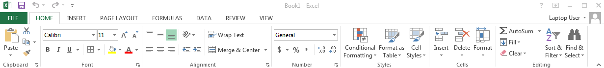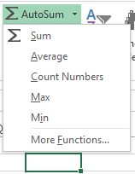

Quickly calculate and enter common functions like **Sum, Average, Maximum** or **Minimum** by using the drop down on the ribbon.

|  |  |  |  |
| --- | --- | --- | --- |
| **Function** | **Purpose** | **Example** | **Result – See spreadsheet example on back** |
| SUM | Summarizes the sum of the values. | =SUM(B2:B13) | 1530 |
| AVERAGE | The average of the values. | =AVERAGE(B2:B13) | 127.5 |
| COUNT | The number of items. | =COUNT(B2:B13) | 12 |
| MAX | The largest value. | =MAX(B2:B13) | 155 |
| MIN | The smallest value. | =MIN(B2:B13) | 100 |
| TODAY | Returns the current date. | =TODAY( ) | 9/16/2015 |

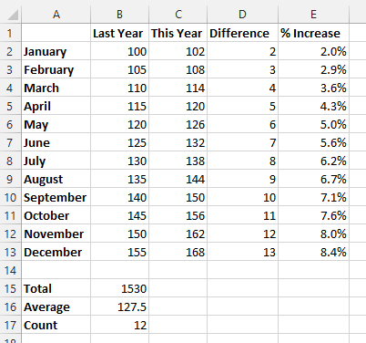

**CALCULATING PERCENTAGES**

To calculate **% increase** (or **% difference**) use this:

**(New Value – Old Value)/Old Value**

Or, if you have a column with the difference already calculated, use **Difference/Old Value**

In the example on the right, the formula in cell **E2** is **=D2/B2**  **(2/100) = 0.02 2.0%**

*Note: Cells E2:E13 are formatted in the Percent*

*format*



**TROUBLE SHOOTING TIPS**

* When numbers suddenly change to **####** it means that the cell is too narrow to display them. Widen the column by placing the cursor on the column border and dragging it to the right until there is enough space.
* When a cell contains **#VALUE!**,the formula in the cell contains nonnumeric data or function names that cannot be used in the calculation.
* You will get a circular reference error if you have a formula that has a reference to the cell in which you want the calculation to appear
* A green triangle in the upper left corner of a cell means possible error. Click on the cell, then click on the **Warning** indication to the left of it.

