
MS Excel: Formulas & Functions – Additional Practice
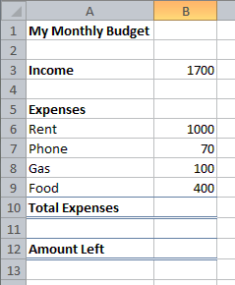
Activity 1
What formula calculates your total expenses?
What formula calculates your Income minus your total expenses?
- Open a new, blank workbook in Excel
- Using the example, create a simple monthly budget for your income and expenses
- Enter the proper formulas in the Total Expenses and Amount Left fields

Activity 2

- Open a new tab (worksheet) in your workbook
- Using the example below, create a yearly budget for your income and expenses. Leave all the Total fields and Monthly Average/Min/Max fields blank
- Use the SUM function to calculate a Total for January Income. Fill the formula across the row.
- Use the SUM function to calculate a Total for January Expenses. Fill the formula across the row.
- Use the SUM function to calculate the Total Yearly Income and Yearly Expenses
- Use the AVERAGE, MIN, and MAX functions to calculate the totals for the appropriate cells.

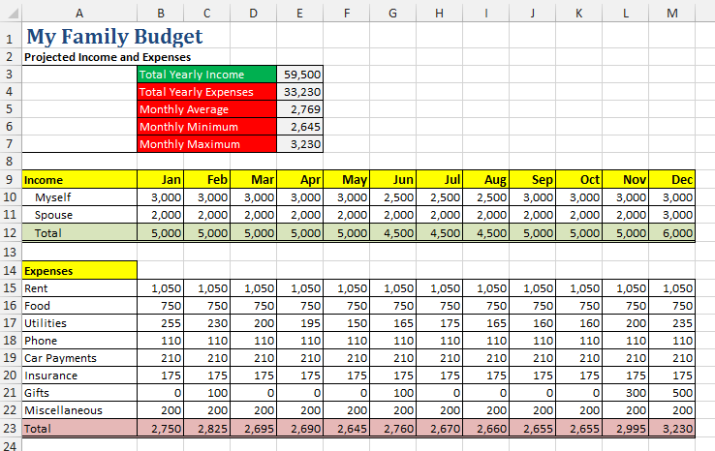
=AVERAGE(B23:M23)
=MIN(B23:M23)
=MAX(B23:M23)

