
Activity Sheet: MS Excel – Formulas & Functions

Activity #1
- Open Practice File- Formulas & Functions. It will appear as below:
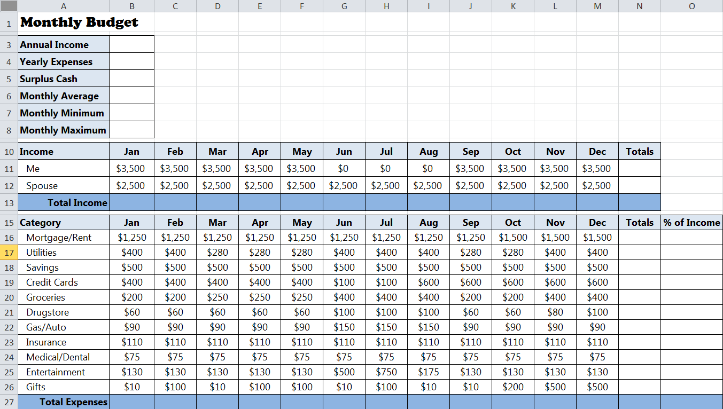

- In the TOTAL INCOME box below the Jan column, enter the correct formula to calculate the income for January [=B11+B12].
- Copy and paste (or fill) the formula from cell B13 into cells C13:M13 to find income totals for the months of February through December.
Activity #2
- In the Total Expenses box below the Jan column, use the AutoSum button to put a formula in cell B27 to calculate the expenses for January [=SUM(B16:B26)].
- Copy and paste (or fill) the formula from cell B27 into cells C27:M27 to calculate income totals for the months of February through December.
- Put a formula in cell N16 to total the cells in B16:M16, using the SUM function. Then copy (or fill) the formula in cell N16 into cells N17:N26. Do the same to get the totals in N11 and N12.
- Copy the formula in M13 to N13.

Activity #3
- Calculate the % of Income the mortgage accounts for in cell O16.
- Use the Auto-fill function to calculate the % of Income for each remaining expense category in cells O17:O26.
- Edit each formula so that the first number in each formula is divided by cell N13 (i.e., =N17/N13, =N18/N13, =N19/N13, and so on)
Activity #4
- Use the SUM function to calculate the total income for the year in cell B3.
- Use the SUM function to calculate the total annual expenses in cell B4.
- Enter the correct formula to calculate the total yearly SURPLUS CASH in cell B5.
- Use the Average function to calculate the Monthly Average in cell B6 [=AVERAGE(B27:M27)].
- Use the MIN function to calculate the minimum monthly expenses for the year [=MIN(B27:M27)].
- Use the MAX function to calculate the maximum monthly expenses for the year [=MAX(B27:M27)].
The completed chart should look like the one below:


