Additional Activity Sheet: MS Excel – Charts & Graphs

- Open a new Excel Workbook
- Type the text and numbers listed in cells A1:B8 (as shown below)
- Select cells A5:B8.
- From the Insert tab, click on Recommended Charts, then Clustered Bar
- Make the Chart Title read Team Progress
- Click the Chart Style button 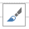 and choose a style to make the bars wider. Hint: choose Style 4 or Style 5.
- Change color of the bars using the Fill Color button.
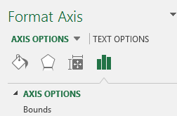
- Change the scale of the horizontal axis to go to 300.
Hint: right-click any of the numbers at the bottom ->Format Axis. In the Format Axis task pane, make sure the Axis Option icon is selected, and look at the Bounds.
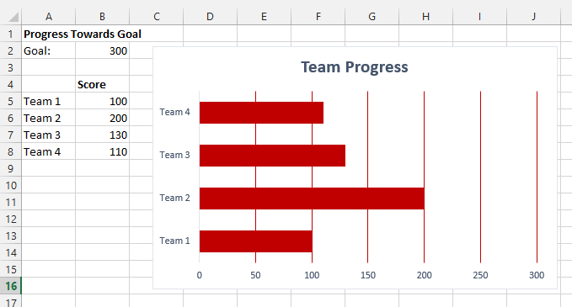
- Make other changes to experiment with formatting, such as changing the color of the plot area or gridlines.
Bar Chart

