
Activity Sheet: MS Excel – Charts & Graphs
Activity #1
- Open Practice File- MS Excel Charts & Graphs and click on the January Budget for Editing worksheet tab at the bottom of your screen (it will look like the one below):
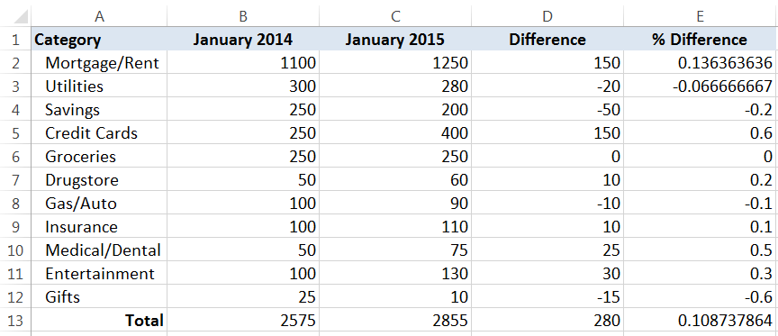

- Adjust the borders and formatting as follows:
  - Add a Top and Double Bottom Border to cells A13:E13
  - Add an Outside Border to cells A1:E1
  - Adjust cells B2:D13 so they are in Accounting format and verify that Decimal Places are set to 2.
  - Adjust cells E2:E13 so they are in Percentage format
Activity #2
- Highlight cells A1:C12
- Click on the Insert tab, and then on the Column button Select Clustered Column
ACTIVITY #3
- Click in the upper right-hand corner of the chart to move it to the area below your data cells
- Click in the upper right-hand corner of the chart and drag the handle up to enlarge your chart
- Click in the Chart Title box and change the text to read “Budget Comparison”
- From the Design tab in Chart Tools, click on the Add Chart Element button to move the legend to the top of the chart
- On the Design tab, click the down arrow in the Chart Styles group and select a different design option for your chart
- Bold the values in your vertical axis and change the text in your horizontal axis to Segoe UI
Activity #4
- Right-click on the vertical axis in your chart and select Format Axis
- Under Bounds, change the Minimum value to 10 and the Maximum value to 1300
- From the Number options, change the Category to display as Currency
- With your chart selected, click the Print button to see a preview of your chart
- Click the January Budget (Edited) worksheet tab at the bottom of your screen to compare your work to completed version, which mirrors the one below.


