
Microsoft Excel: Advanced Topics
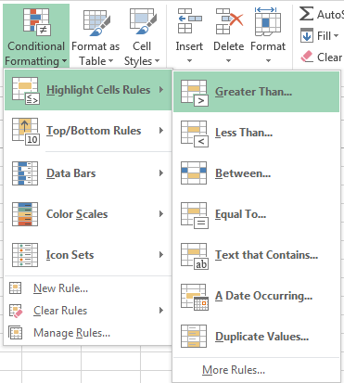
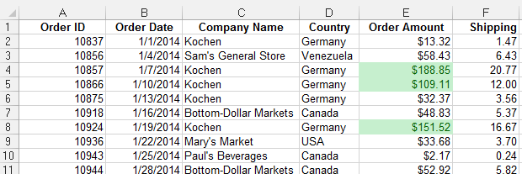

Conditional Formatting
- Select the cell(s) you want to format.
- Click the Home tab > Conditional Formatting and select the desired option

To clear the rules
- Select the cell(s)
- Click the Home tab > Conditional Formatting > Clear Rules > Clear Rules from Selected Cells

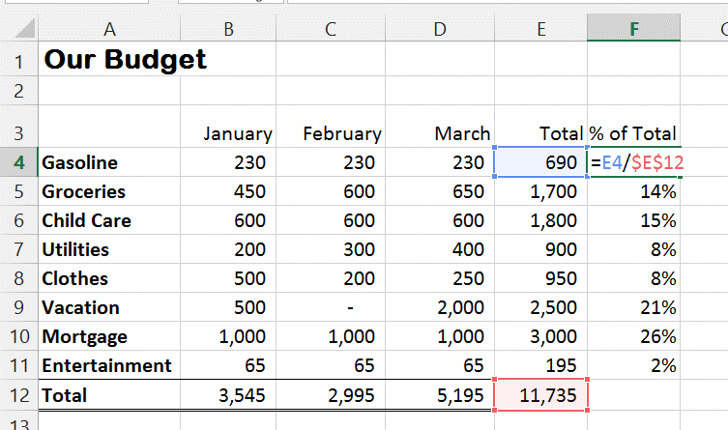

Absolute references
If you don't want references to change when you copy a formula to a different cell, use an absolute reference. To insert one, place a dollar sign ($) before the parts of the reference that should not change.
Ex: =E4/$E$12
Tip: Press the F4 key while entering or editing a cell address to make it absolute.

To create a formula with a reference to another workbook/worksheet
- Type the formula in the appropriate cell.
- Include the “source cell” by switching to the worksheet it is located on and clicking on the cell.
- Press Enter (unless additional cell references are needed).

The reference will include the worksheet name: ='1st Quarter'!E4

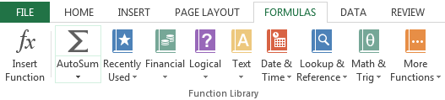
Ways to enter a function
- Type it in the cell
- Use the Insert Function [ fx] button
- Use the buttons in the Function Library under the Formulas tab

Every function has a specified structure. It set up like this: Function Name (arguments).
Example: PMT(rate,nper,pv,fv,type)

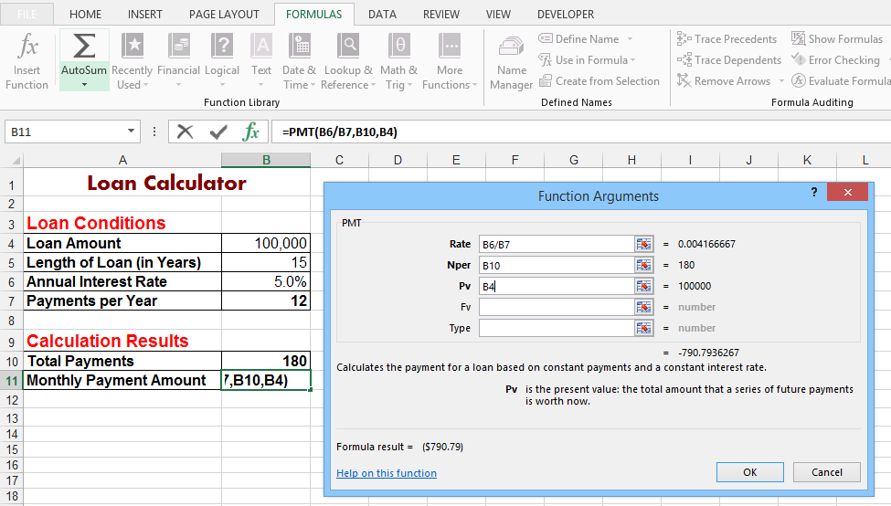

Payment function
- Click the cell where you want the result
- Click the Formulas tab > Financial button> PMT
- In the Function Argument dialog box, enter the following:
- Interest Rate per month (Rate)
- Number of payments (Nper)
- Loan amount (Pv)
- Click the OK button

Note: To see the Function Argument dialog box after you have completed entering the function, click the cell containing the function followed by the fx button on the formula bar.

Using VLOOKUP to find values in a table
- Create a lookup table containing the values you want to find. These values, called compare values, must be in the leftmost column. If you are looking up values in a range (see step 7), the Compare Values must be sorted in ascending order.
- Click the cell in which you want the result to appear.
- Click the Formulas tab > Function Library > Lookup & Reference > VLOOKUP
- Click the Lookup_value box then click the cell that contains the value you want to find
- Click the Table_array box and select the cell range of the lookup table. If you will be copying the formula later, press the F4 key to make the range reference an absolute address.
- In the Col_index_num box, type the number of the lookup table column in which to find a corresponding value. Think of the columns as being numbered, left to right, starting with 1.
- In the Range_lookup box, decide if you want to find the closest match or an exact match. For the closest match, leave the box empty; for an exact match, type False.
- Click the OK button. The VLOOKUP function results will be in the second column.



