
Microsoft Excel: Advanced Topics
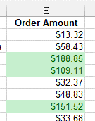
ACTIVITY #1
- Open the Market Orders file
- Select cells E2:E74 (the Order Amount)
- Use Conditional Formatting to highlight in green all the orders over $100
- Use Conditional Formatting to highlight in red all the orders less than $10
- Clear the Conditional Formatting rules

Activity #2
- Open the Budget file. Determine which cells contain formulas.
- Enter the word “Total” in cell E3.
- Enter a formula in cell E4 to show the Total amount for Gasoline
- Fill the formula in E4 down to the rest of the cells (down to cell E12)
- Use Conditional Formatting to add Data Bars to the numbers in the Total Column (don’t format the grand total)
- Type “Percent of Total” in cell F3
- In cell F4, create a formula to divide cell E4 by E12. Format cell F4 in the Percent format.
- Modify the formula in F4, to make the reference to E12 an absolute reference.
- Copy the formula down through F11.

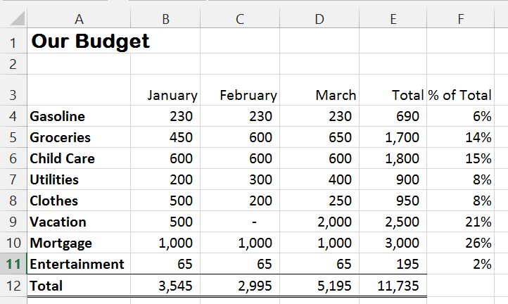

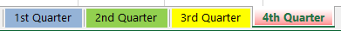

Activity #3:
With the Budget file:
- Change the color of each of the sheet tabs.

Activity #4:
With the Budget file:
- Go to the 2nd Quarter sheet. In cell G3, type “1st Quarter”
- Enter a formula in cell G4 to display the value in cell E4 of the 1st Quarter sheet.
- Fill this formula down to cells G5:G11
- Go to the 1st Quarter sheet. Change the value of Groceries in January to 500. Note how the January total is changed. Go back to the 2nd Quarter sheet and see the change there also.

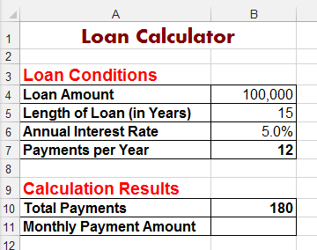

Activity #5
- Open the Loan Calculator file
- Type the values for the Loan Amount, Length of Loan, and Annual Interest Rate as shown in the picture.
- Look at the contents of cell B10. What is the formula used in cell B10?
- Use the PMT function to create a formula in cell B11 to calculate the monthly payment.

Activity #6
- Open the Vehicle Order Example File.
- Look at the Price List table on the right. This will be your Lookup table.
- Click in cell D2.
- Use VLOOKUP to determine look up the price in the Lookup table for the Vehicle ID in cell B2. Hint: the Table Array will be $J$2:$P$73
- Fill the formula down for the rest of the orders.
- Change the Vehicle number for the third order to 897. Notice how the price changes.
- Add a new order line with the current date for Vehicle number 1016. Fill a customer name and copy the formula from above to look up the price.



