
Microsoft Word 2010: Tables, Images & Graphics
Inserting a Table
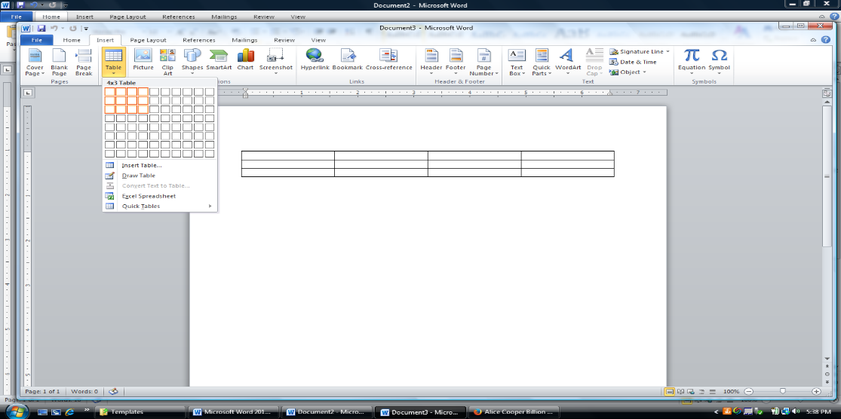
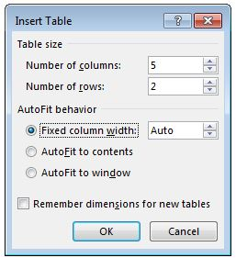
From the Insert tab, click the Table icon and move the mouse over the desired number of table cells from the grid.
Note: For more options or a larger size, click Insert Table and enter the columns and rows.

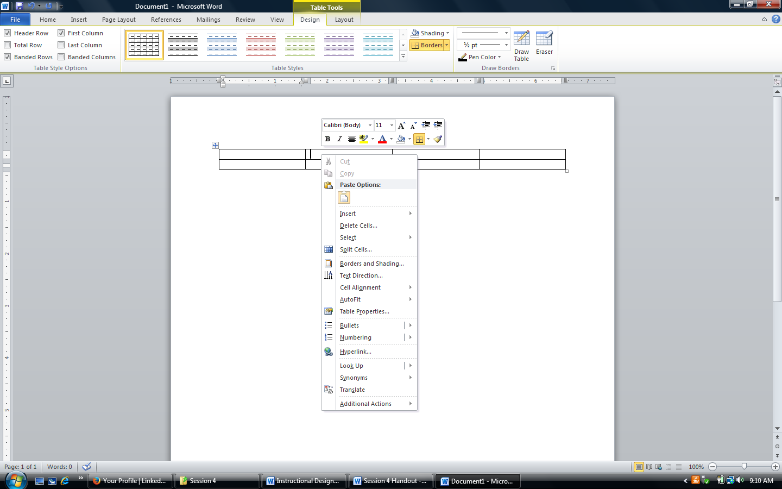

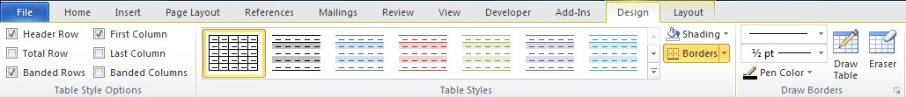
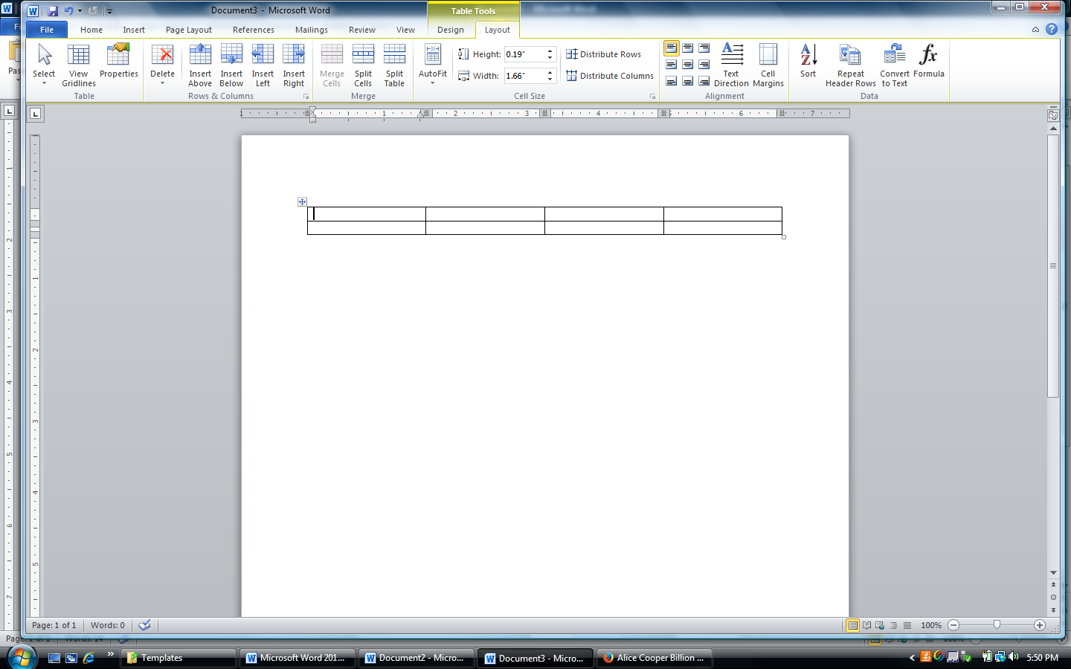
Designing & Formatting a Table
Tables Tools offers two areas of customization options: Design and Layout. The Design tab allows for styling edits such as color, border, shading, etc. to make tables more visually appealing.
The Layout tab includes properties of the table like adding/deleting cells, text alignment within the cells, adjusting column/row height, etc.
Right-click on the table to access the mini menu for quick formatting. Use the Design & Layout tabs from the toolbar for more options.

Inserting Clip Art
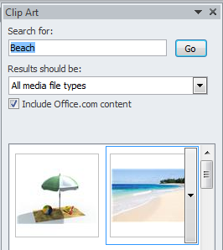
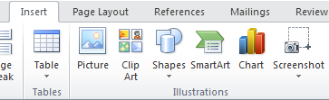

Inserting a Picture File

From the Insert tab, click Clip Art. A window opens where you can search the database for images. Enter a keyword, like beach, and click on the image to insert it.

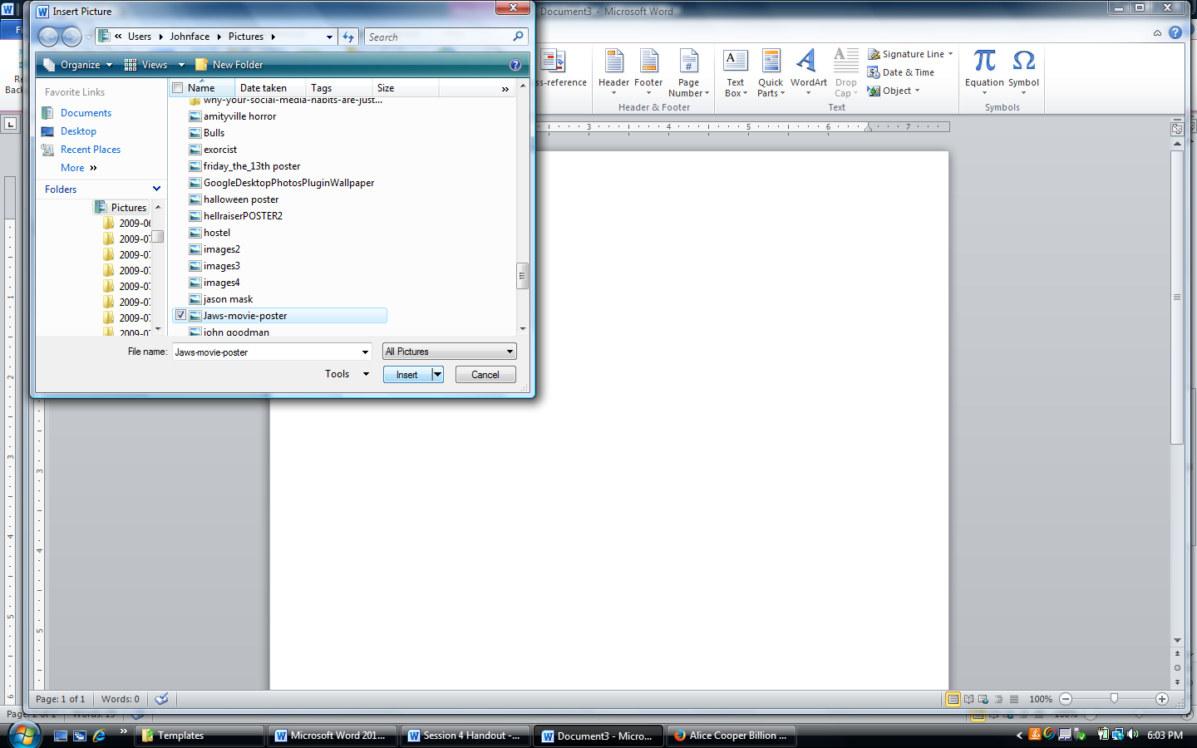

From the Insert tab, click Picture. A window opens where you can search your files for an image. Click insert when you have selected your image(s).

Formatting with Picture Tools
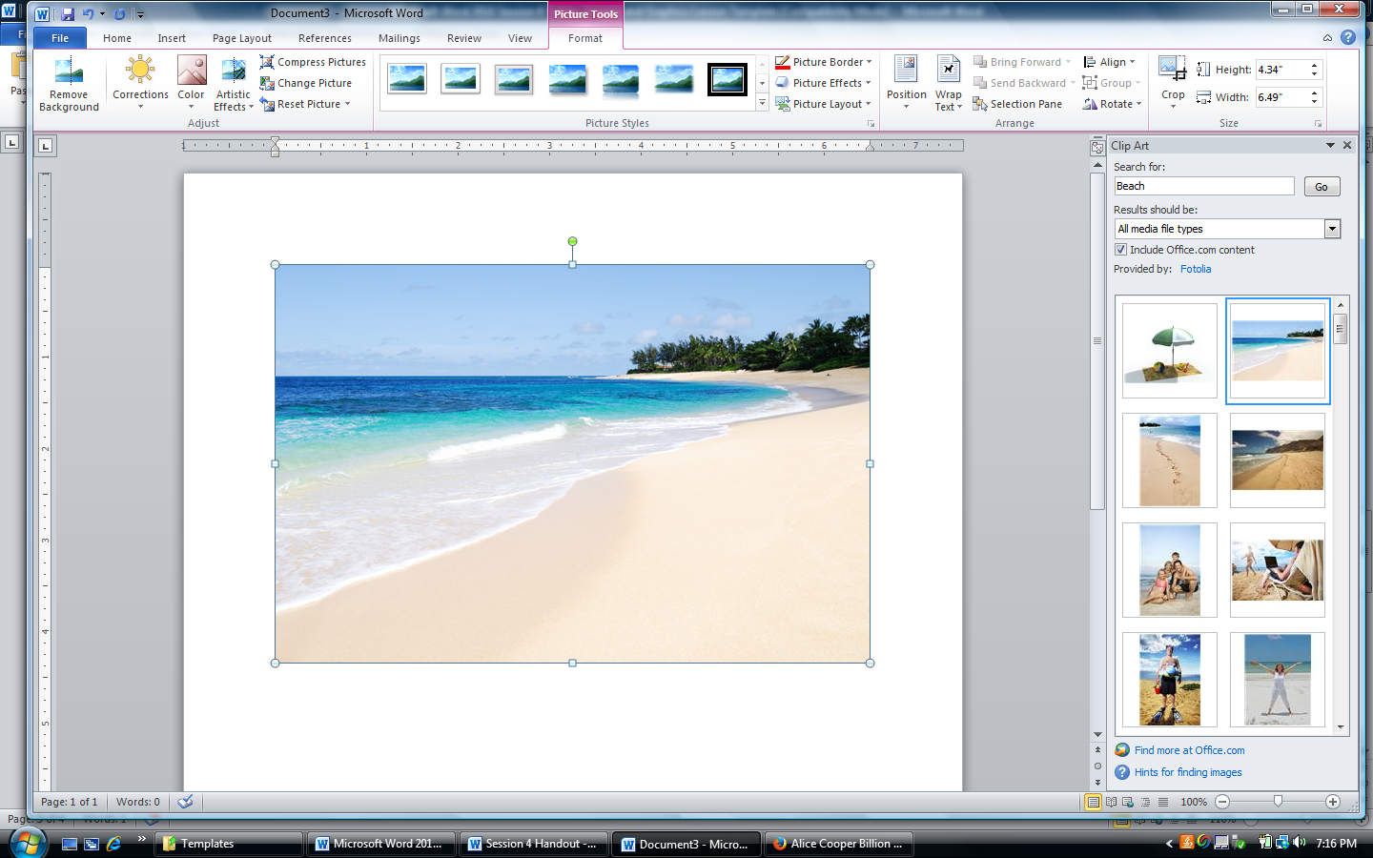
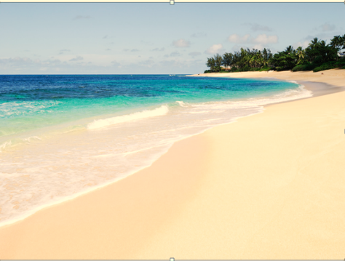
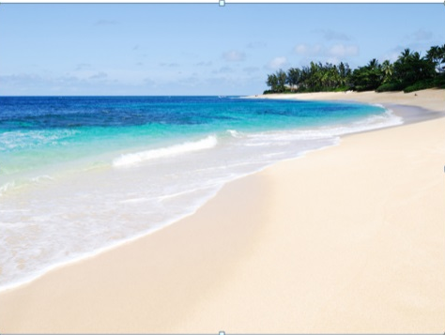
When an image is selected, the Picture Tools will be available by clicking on the tab. Use features such as Corrections, Color, Borders, Crop and Rotation to format pictures.

