
MS Word 2010 Formatting Documents

THE FONT GROUP (Located on the Home Tab)
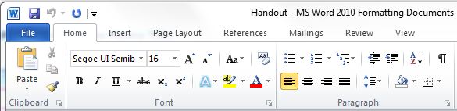

FONT FORMATTING TOOLS
Bold, Italics, Underline, Strikethrough, Subscript, Superscript
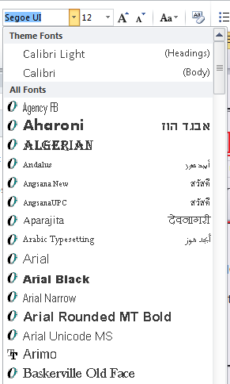
Font Style

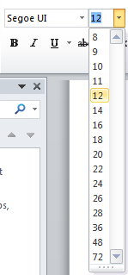
Font Size
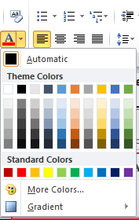
Font Color

THE PARAGRAPH GROUP (Located on the Home Tab)

PARAGRAPH FORMATTING TOOLS
Alignment (Left, Middle, Right or Justify)
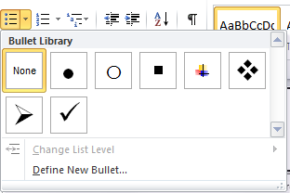
Bullet List

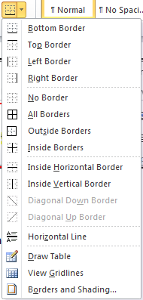
Borders & Shading

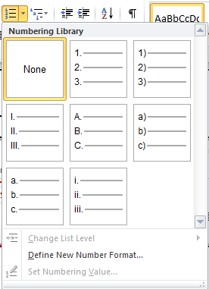
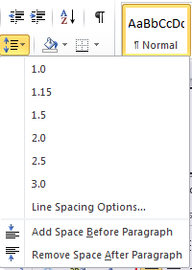
Number List
Line Spacing

