
Microsoft Word 2010: Editing Tools
Cut: Moves an item to the Clipboard for insertion into another location or document
Copy: Places a copy of an item on the Clipboard for insertion into another location or document
Paste: Inserts an item from the Clipboard into a document

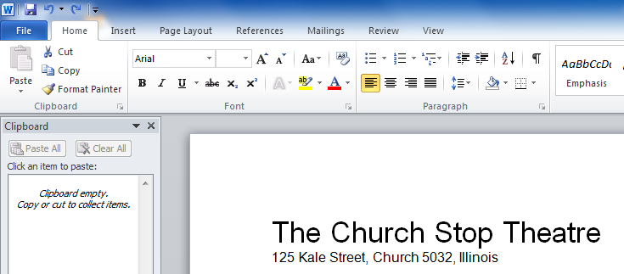
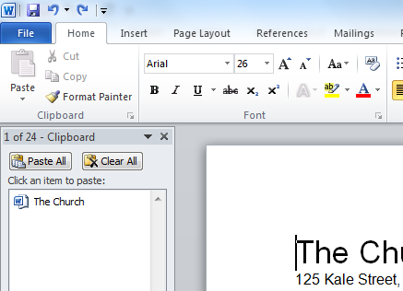
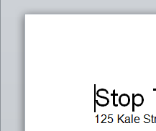
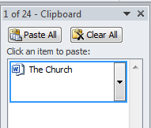


Cutting & Pasting
- On the Home Tab, click the dialog box launcher in the lower-right hand corner of the Clipboard Group
- Highlight the text or object you wish to cut and paste
- Click the Cut button in the Clipboard group
- Click the area on the document where you want to insert the item
- Click on the item in the Clipboard pane to Paste it

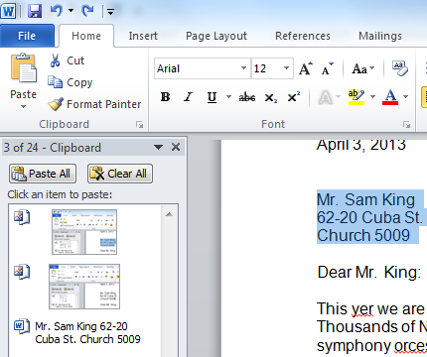
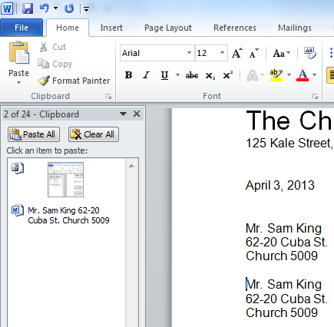
Copying & Pasting – Copying items follows the same procedure as cutting. To Copy items, click the Copy button in place of the Cut button

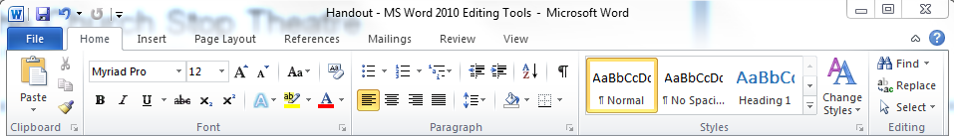
Finding Text
- From the Home Tab, click Replace in the Editing Group
- Click the Find tab in the Find and Replace window
- Type the word(s) in the Find box
- Click the down arrow in the Find In drop-down list and select Main Document to find all instances of the word(s) in the document

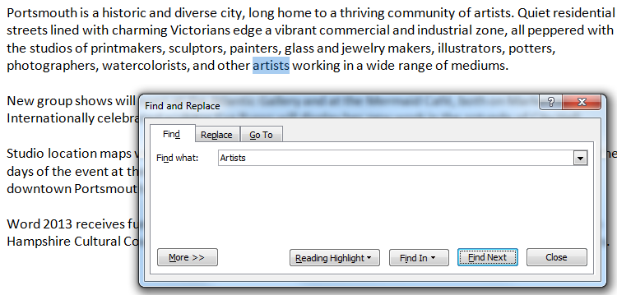
Replacing Text – Replacing text follows a similar procedure to Finding. To replace text, use the Replace tab in the Find and Replace window and enter the appropriate text in the boxes. Select one of the following options:
- Replace: Replaces the first instance of the word(s) in the document
- Replace All: Replaces all instances of the word(s) in the document
- Find Next: Replaces the first instance of the word(s) in the document and then moves to the next instance of the word(s), so you can review one-by-one

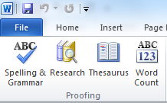
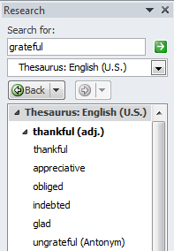

Using the Thesaurus
- Click the Review tab
- Highlight a word
- Click the Thesaurus button in the Proofing group
- A synonym list appears in the Thesaurus pane

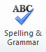
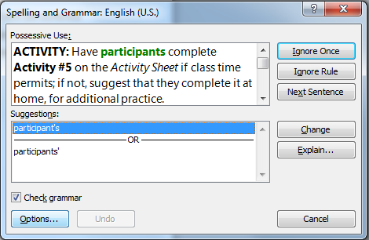
Spelling & Grammar
While typing in a document, Word will display spelling and grammar errors
- Red underline = spelling errors
- Green underline = grammatical error
View Word’s suggested corrections by clicking the Spelling & Grammar button on the Review Tab where you can Ignore Once, Ignore All, Add to Dictionary, Change All, or AutoCorrect

