
MS Word 2010 Basics

BASIC ELEMENTS OF THE PROGRAM WINDOW
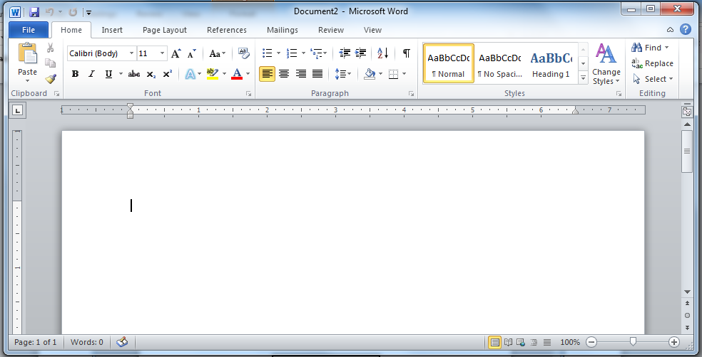
View Buttons
Zoom Slider
Quick Access Toolbar
Document Window
Horizontal & Vertical Rulers
Title Bar
Status Bar
Minimize, Maximize, Close
Scroll Bar & Arrows

THE RIBBON
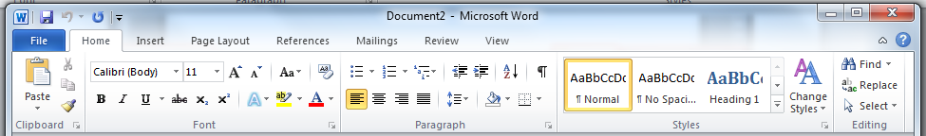
File Tab
Tabs
Groups
Launcher

Tab Groups
Home Clipboard, Font, Paragraph, Styles & Editing
Insert Pages, Tables, Illustrations, Links, Header/Footer, Text, & Symbols
Page Layout Themes, Page Setup, Page Background, Paragraph, & Arrange
References Table of Contents, Footnotes, Citations, Captions, Index, & Table of Authorities
Mailings Create, Start Mail Merge, Write/Insert Fields, Preview Results, & Finish
Review Proofing, Language, Comments, Tracking, Changes, Compare, & Protect
View Document Views, Show, Zoom, Window, & Macros
The exception is the File tab which includes general commands with file options. On this tab you will find Save, Save As, Open, Close, Info, Recent, New, Print, Save & Send, Help, Options, Exit.

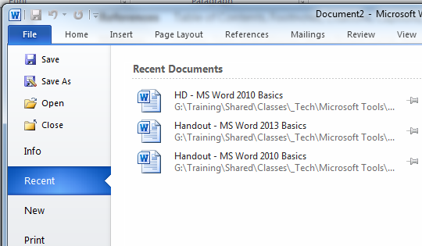
SAVE & SAVE AS
SAVE AS
- Click File
- Click Save As
- Select the location
- Name the document
- Click Save

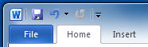
Save

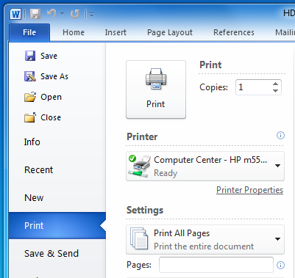
PRINTING
PRINTING
- Click File
- Click Print on the menu
- Check Printer Settings & adjust if necessary (Copies, Pages, Double-Sided, etc.)
- Click the Print button



