
MS Publisher 2010: Basics
BASIC ELEMENTS OF THE PROGRAM WINDOW
Quick Access Toolbar
Document Window
Horizontal & Vertical Rulers
Title Bar
Minimize, Maximize, Close
Scroll Bar & Arrows
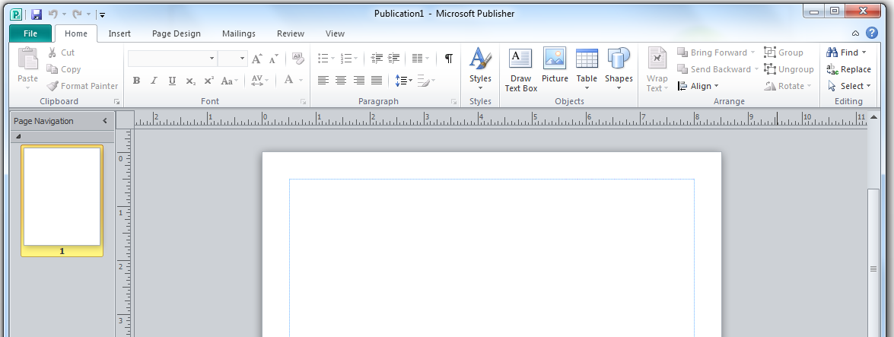

Page Navigation

THE RIBBON
File Tab
Tabs
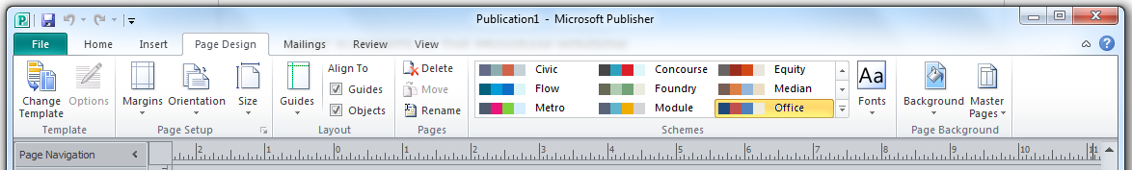

Group

Tab Groups
Home Clipboard, Font, Paragraph, Styles & Objects
Insert Pages, Tables, Illustrations, Building Blocks, & Text
Page Design Page, Layout, Pages, Schemes, & Page Background
Mailings Start, Write & Insert Fields, Preview Results, & Finish
Review Proofing & Language,
View Views, Layout, Show, Zoom, & Window
The exception is the File tab which includes general commands with file options. On this tab you will find Save, Save As, Open, Close, Info, Recent, New, Print, Save & Send, Help, Options, Exit.

SAVE & SAVE AS
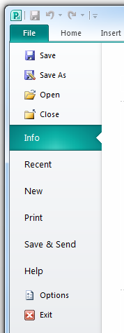
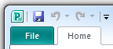
SAVE AS
- Click File
- Click Save As
- Select the location
- Name the document
- Click Save
Save

PRINTING
PRINTING
- Click File
- Click Print on the menu
- Check Printer Settings & adjust if necessary (Copies, Pages, Double-Sided, etc.)
- Click the Print button

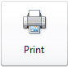

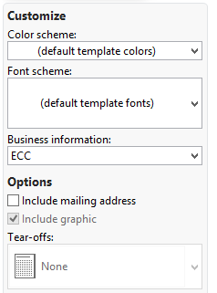
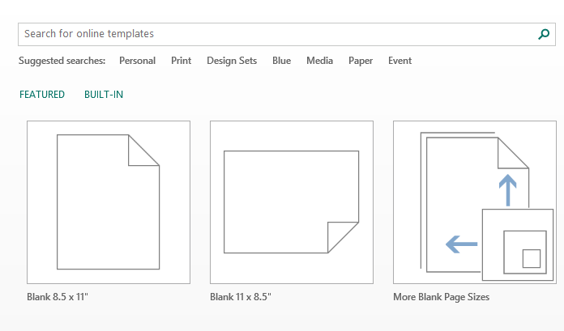
SELECTING A TEMPLATE TO USE
- Open Publisher
- Click Built –IN to access template categories
- To see more templates within a group, click All
- Click on the desired design
  - On the right-hand side, under Customize, change your Color, Font and Font scheme
  - Under Options:
- If your flyer is going to be folded and mailed without an envelope, put a check mark by Include mailing address
- Select a Tear-off, if necessary (Depends on template type)
- Click Create on the lower right

