
Microsoft PowerPoint: Special Effects
The Insert Tab

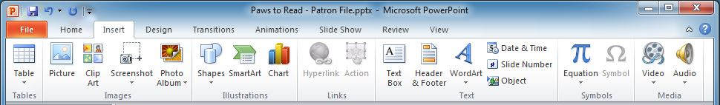
Shapes
Charts
Text Box
WordArt
Screenshot

The Drawing Tools Tab – The Drawing Tools tab appears on the Ribbon when a text box, shape or WordArt is selected. It allows you to modify color, size, and other features

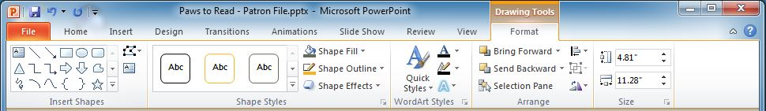

The Picture Tools Tab – The Picture Tools tab appears on the Ribbon when an image (picture or screenshot) is selected. It allows you to add artistic effects and frames, adjust color, crop and more

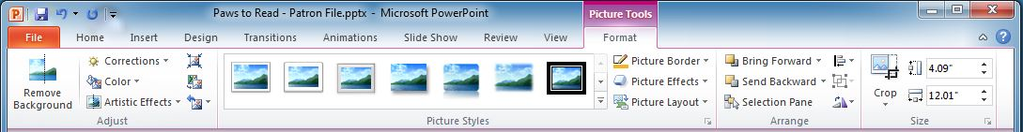

The Chart Tools Tab – The Chart Tools tab appears on the Ribbon when a chart is selected. Chart tools offers Design & Format options allowing for overall adjustments and individual chart elements

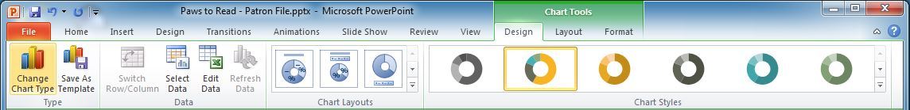

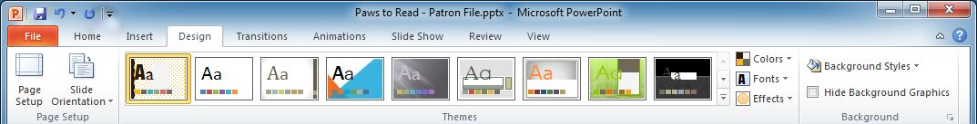
Color Variants
Format Background
Page Setup & Slide Size
The Design Tab

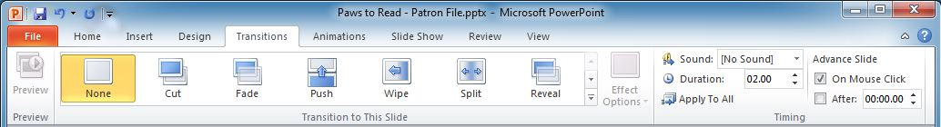
Apply to All Slides
The Transitions Tab

The Animations Tab

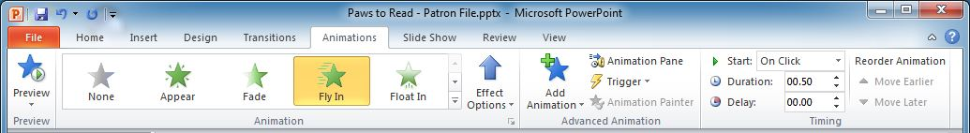

Printing

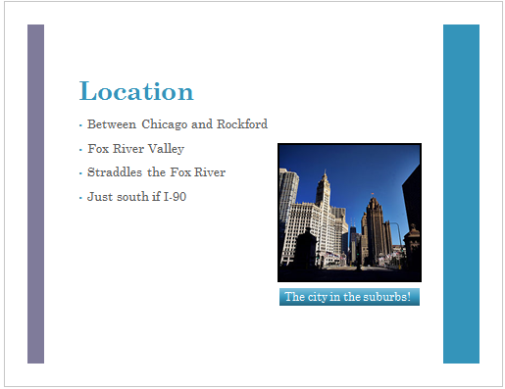
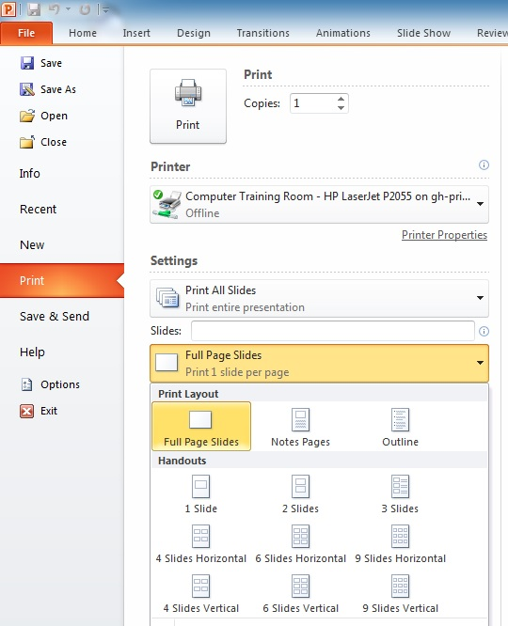
3 Slide Handout
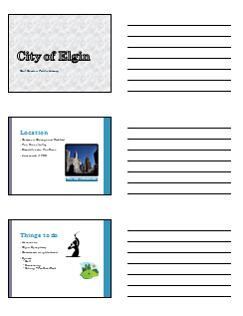

Full Page Slides

