
Microsoft PowerPoint: Basics
Terminology
PowerPoint | An application for creating custom slide show presentations
Ribbon | The area where commands are organized into Tabs, icons, & Groups
Tabs | The areas within the Ribbon where like features are organized
Groups | The areas within Tabs where related task functions are organized
Slide | Each individual screen in a PowerPoint presentation
Navigation Pane | The display pane on the left side of the PowerPoint window that provides a preview of all slides in your presentation and allows for quick navigation
Layout | The pre-arranged placeholders on each slide allowing for content to be quickly added
Themes | Pre-designed background graphics, color combinations, and font pairings that enhance the image of your slides
PowerPoint Program Window

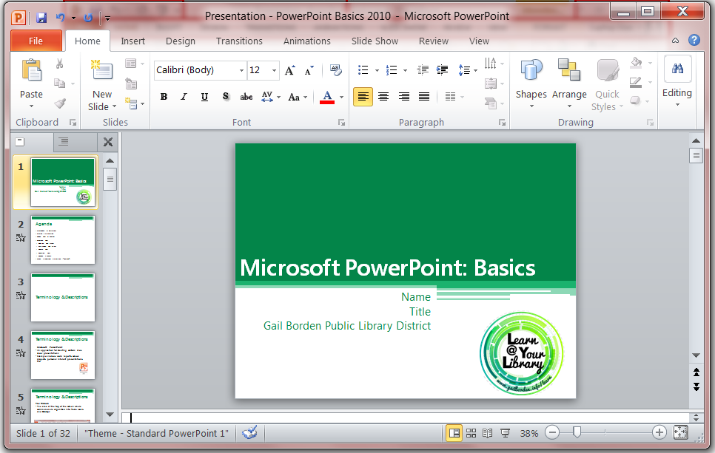
Quick Access Toolbar
Tabs
Minimize, Maximize, Close
Groups
The Ribbon
Navigation Pane
Slide
Zoom Slider

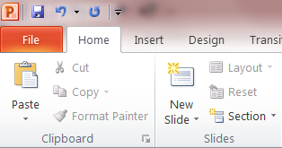
    - Click on the Home tab
    - Click on the New Slide button
    - Enter the appropriate content in the boxes provided (Hint: Use the Insert tab to add images, graphs, etc.)
Adding a New Slide

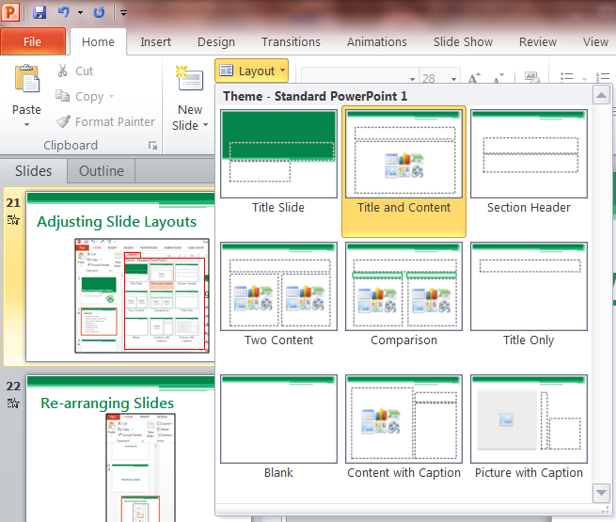
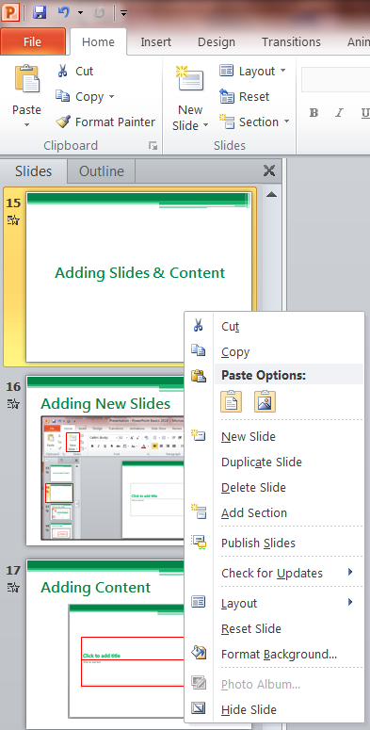
Adjusting Slide Layouts
- Click on the appropriate slide
- Click on the Home tab
- Click the Layout button and use the drop-down menu to select the desired layout
Using the Navigation Pane
Duplicating Slides
- Right-click on the appropriate slide
- Click on Duplicate

Deleting Slides
- Right-click on the appropriate slide
- Click on Delete Slide to remove it

Re-arranging Slides
- Click on the appropriate slide
- Drag it to the intended position

Applying a Theme
- Click the Design tab
- Click on a theme to apply it.
(Hint: Apply themes to one or all slides. Right-click on a theme for more options.)
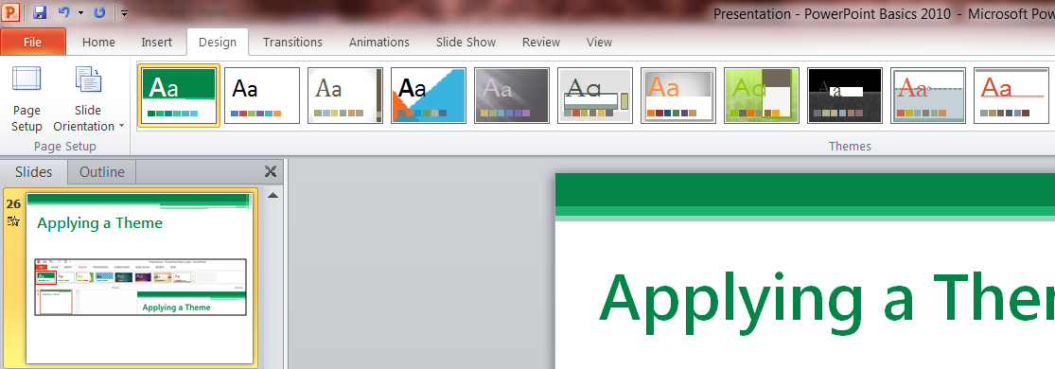

Playing a PowerPoint Presentation (“Slide Show”)

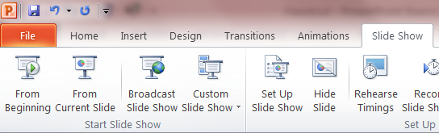
- Click the Slide Show tab
- Click the From Beginning button
- Enjoy the show by clicking through the slides
- Click at the end to return

