
Microsoft Excel 2010: Working with Tables

STRUCTURED RANGE
In order to create a Pivot Table, it is useful to begin with a Structured Range (a list that contains a set of data, such as invoice numbers and amounts). Tips for creating a structured range:
- Label each column in the list. The labels should be formatted differently than the rest of the data (usually bold).
- The same type of data should be in each column, such as all text or all numbers
- Avoid blank rows or columns in the range
- Don’t insert extra spaces at the beginning of a cell as they affect sorting and spacing.
- Avoid having more than one range on a worksheet because some features, such as filtering, can be used on only one list at a time.
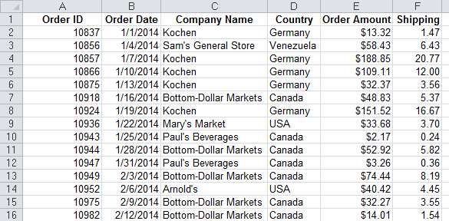


Sorting a list
- To sort by a single column, select a single cell in that column and click Sort A > Z on the Data tab

- To sort by more than one column, select a single cell in the list and click the Sort button on the Data tab

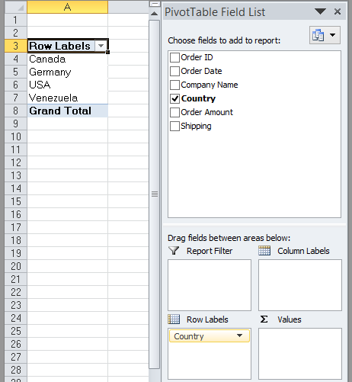
Pivot Tables
A Pivot Table quickly summarizes, or cross-tabulates, large amounts of data. To create a Pivot Table complete these steps:
- Click on any cell in the range
- On the Insert tab, click on Pivot Table
- Verify that the range is correct and click OK
- Click to check the fields you want to display
- If needed, drag a field from one area at the bottom to another (ex: row label to column label)
Note: Pivot Tables open in separate worksheets.

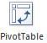

See the example below. The company name is used as the Row Label and the country is used as the Column Label. The Order Amounts are the Values.

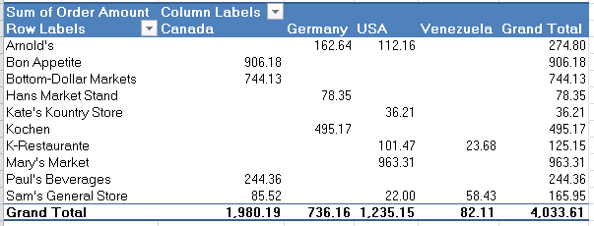

To format a Pivot Table
- Click inside the Pivot Table
- Choose one of the Styles under the Pivot Table Tools from the Design tab.

To update a Pivot Table (When the Data changes):
- Click in the Pivot Table
- Under the Pivot Table Tools,
click the Options tab, then Refresh





