Quick Reference Guide:

Microsoft Excel 2010: Charts & Graphs

[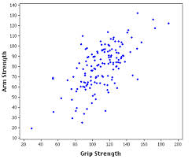](http://www.google.com/url?sa=i&rct=j&q=&esrc=s&source=images&cd=&cad=rja&uact=8&docid=lBjYv-7QZ-zEmM&tbnid=HjIMLsDKqDN75M:&ved=0CAUQjRw&url=http://davidmlane.com/hyperstat/A60659.html&ei=WLkMVIjHEIKzyATi2oGoCA&bvm=bv.74649129,d.aWw&psig=AFQjCNE-5N5K6SkCLdItA-GqzVeSaGpLbg&ust=1410206154858365)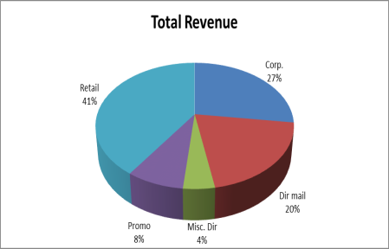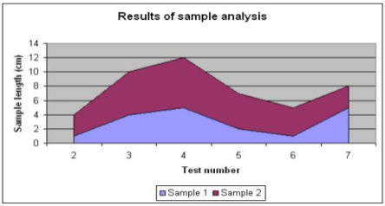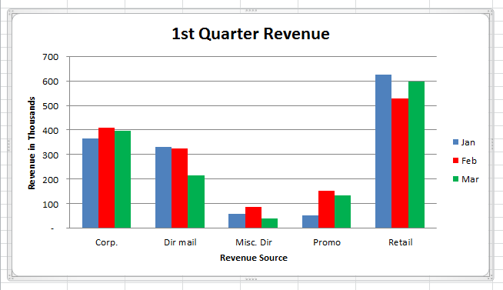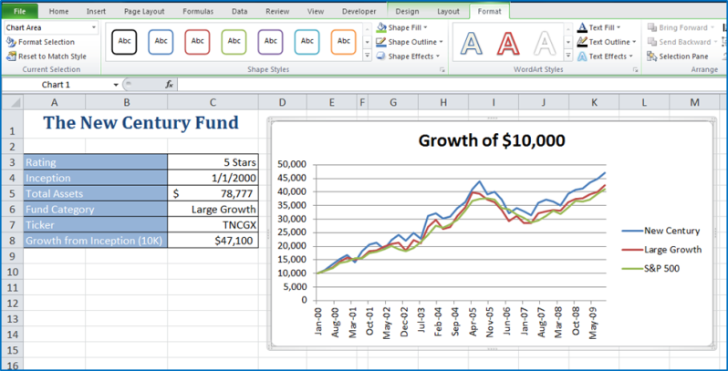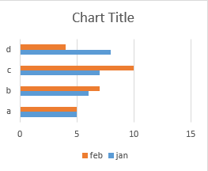

**Column Charts** - Compare distinct items or show single items at distinct intervals. Values are indicated by the height of the columns. Ex: Display how values change over time.

**Line Charts** - Use a series of consecutive points to plot a variable value over time and show you a trend. They imply a pattern of change over time.

**Pie Charts** - Show the relationship between one or more “pieces” of the pie in comparison to the whole pie. Great for demographic data, budget info, sales figures, etc. They provide snapshots for specific periods of time.

**Area Charts** - Show the relative contributions over time that each data series makes to a whole picture. Ex: Showing how much the relative amounts of the principal and interest change over time of a mortgage.

**Bar Charts** - Compare distinct items/show single items at distinct intervals. Useful for comparing data items that are in competition.

**Scatter Plots** – Merely plots the data points against their values. While less visually appealing, the lack of bar, columns or pie pieces can be an advantage since scatter diagrams allow viewers to draw their own conclusions.