
Microsoft Excel 2010: Charts & Graphs
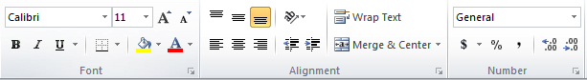
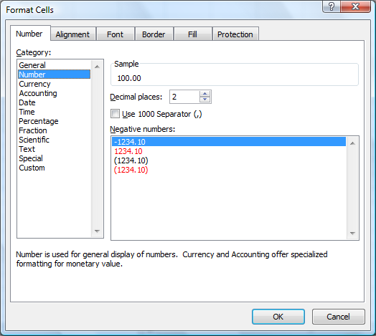
FORMATTING NUMBERS
- Select the cells containing the numbers you want to format
- From the Number group on the Home tab:
  - Use Accounting or Currency format style to add a ($)
  - Use Percent style (%) to display percentages
  - Use Comma style (,) to add commas & decimals
  - Increase or Decrease decimal places
  - Use Format Cells dialog box for more options

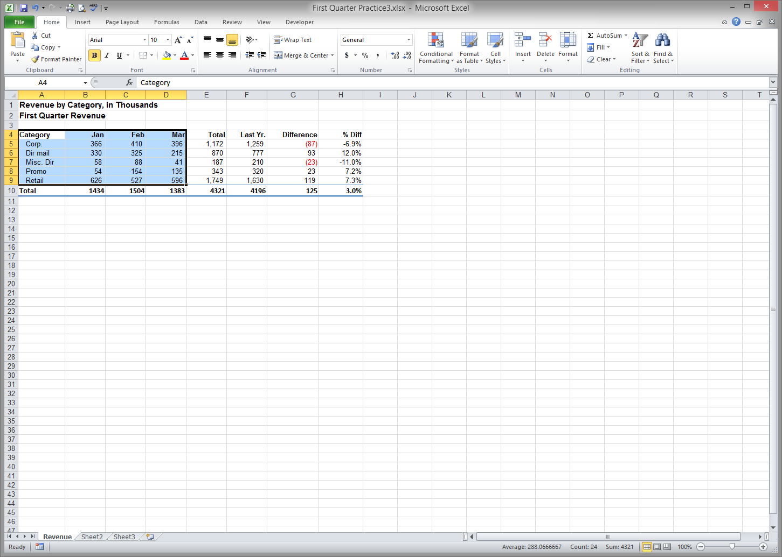
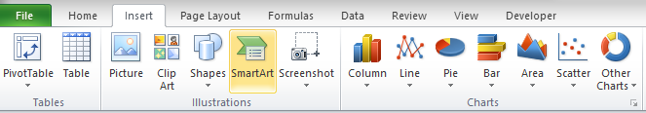
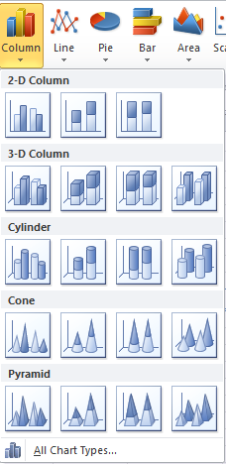
CREATING CHARTS
- Select the cells containing the data and text you want to appear in the chart
- On the Insert tab, select the chart type and subtype in the Charts group.

MODIFYING CHARTS
To change elements in a chart, click the area you wish to change and the Chart Tools tab will appear at the top of the ribbon. Color, Style, and Text options will be under Format. To change Axes, Gridlines, Chart Titles, and the Legend, click on Chart Tools then Layout.

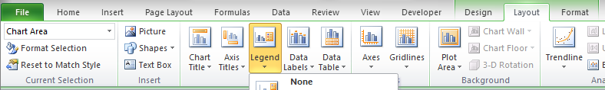

Quick Reference Guide: Chart Types

Column Charts - Compare distinct items or show single items at distinct intervals. Values are indicated by the height of the columns. Ex: Display how values change over time.

Area Charts - Show the relative contributions over time that each data series makes to a whole picture. Ex: Showing how much the relative amounts of the principal and interest change over time of a mortgage.

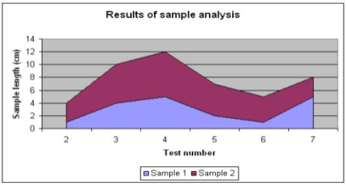
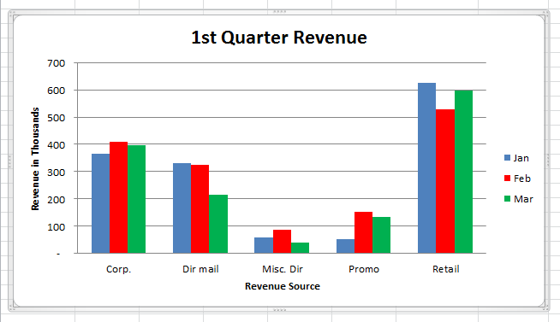

Line Charts - Use a series of consecutive points to plot a variable value over time and show you a trend. They imply a pattern of change over time.

Bar Charts - Compare distinct items/show single items at distinct intervals. Useful for comparing data items that are in competition.

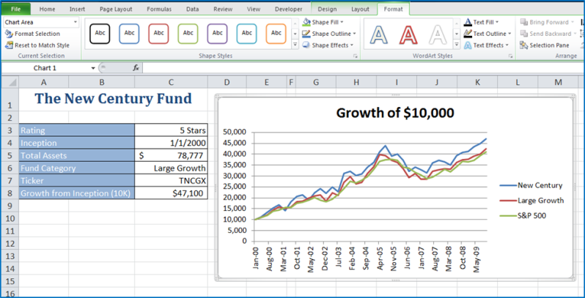
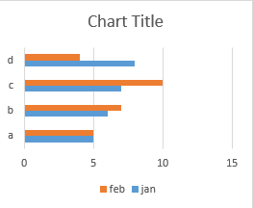

Pie Charts - Show the relationship between one or more “pieces” of the pie in comparison to the whole pie. Great for demographic data, budget info, sales figures, etc. They provide snapshots for specific periods of time.

Scatter Plots – Merely plots the data points against their values. While less visually appealing, the lack of bar, columns or pie pieces can be an advantage since scatter diagrams allow viewers to draw their own conclusions.



