
Activity Sheet: MS Excel 2010: Charts & Graphs
ACTIVITY #1
- Open Practice File- MS Excel 2010 Charts & Graphs and click on the January Budget for Editing worksheet tab at the bottom of your screen (it will look like the one below):
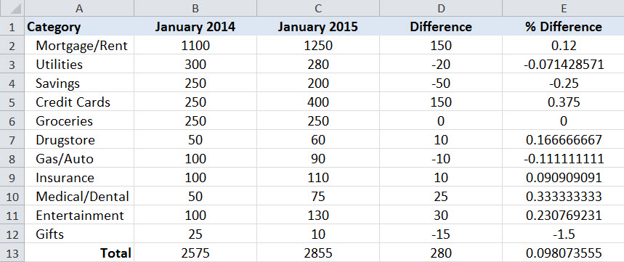

- Adjust the borders and formatting as follows:
  - Add borders to cells A1: E13
  - Add a Top and Double Bottom Border to cells B12:E12
  - Add an Outside Border to cells A1:E1
  - Adjust cells B2:D13 so they are in Accounting format
  - Adjust cells E2:E13 so they are in Percentage format and reduce the number of decimal places to 0
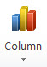
ACTIVITY #2
- Highlight cells A1:C12
- Click on the Insert tab, and then on the Column button ; select Clustered Column
ACTIVITY #3
- Click in the upper right-hand corner of the chart to move it to the area below your data cells
- Click in the upper right-hand corner of the chart and drag the handle up to enlarge your chart
- Click on the Layout tab in the Chart Tools tab to access the Labels group
- Click on the Chart Title button and select the Above Chart option
- Highlight the text and change it to read “Budget Comparison”
- Click on the Legend button inside the Layout tab and move the legend to the bottom of the chart
- On the Design tab, click the down arrow in the Chart Styles group and select a different design option for your chart
- Bold the values in your vertical axis and change the text in your horizontal axis to Corbel
- Click Axes > Primary Vertical Axis > More Primary Vertical Axis options on the Layout tab to access the Format Axis window
- Click Axis Options and change the Minimum to Fixed and adjust the value to 10; change the Maximum to Fixed and adjust the value to 1300
- Click on your chart, and then click the Print button to see a preview of your chart
- Click the January Budget (Edited) worksheet tab at the bottom of your screen to compare your work to completed version. Your chart should look like the chart below.


