
Microsoft Excel 2010: Basics
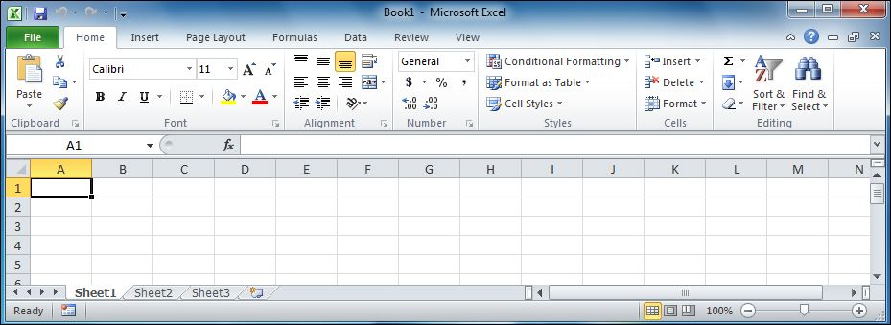
Zoom Slider
Quick Access Toolbar – Includes Save, Undo/Redo and other frequent commands you place there (Ex: Print)
The Excel Window

Ribbon Tabs
Command Group
Dialog Box Launcher
The Ribbon & Home Tab

Tips
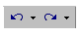
- If you make a mistake when entering data press the ESC key
- To undo an entry, click the Undo button on the Quick Access Toolbar
- To use spell-check, click the Review Tab, then the Spelling & Grammar button
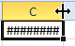
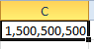
- When numbers suddenly change to #### it means that the cell is too narrow to display them. Widen the column by double-clicking on the right edge of the cell border to auto-adjust the size, as shown below, or by placing the cursor on the column border and dragging it to the right until your achieve the desired width.

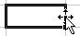
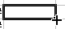
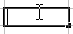
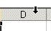
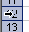
Mouse Pointer Shapes in Excel
Select a cell or range
Drag a selected cell or range
Fill – Copies values or a series of values
Entering or editing data
Resize column
Resize row
Select whole column
Select whole row

Excel Shortcuts – To use a shortcut, press & hold the CRTL key then tap the other key
Command | Press | 2010 Ribbon Tab
Beginning of Sheet | Ctrl+Home
Bold formatting | Ctrl+B | Home
Copy | Ctrl+C | Home
Copy value from cell above | Ctrl+'(Single Quote)
Cut | Ctrl+X | Home
Display all formulas and their values for all formulas on a worksheet | Ctrl+` (Single Left Quotation Mark Above Tab Key) | Formula, Formula Auditing, Show Formulas
End of Sheet | Ctrl+End
Enter the Date | Ctrl+; (Semicolon)
Find | Ctrl+F | Home
Go to a specific Cell | F5 | Home
Hide columns | Ctrl+0 (Zero) | Home, Cells, Format
Hide rows | Ctrl+9 | Home, Cells, Format
Italic formatting | Ctrl+I | Home
Move to next worksheet | Ctrl+Page Down
Move to previous worksheet | Ctrl+Page Up
New line in cell | Alt+Enter
New Workbook | Ctrl+N
Print | Ctrl+P | File Tab
Clear ALL formatting |  | Home, Editing, Clear
Repeat the last action | F4
Save | Ctrl+S | File Tab
Save As | F12 | File Tab
Spelling | F7 | Review
Underline | Ctrl+U | Home
Undo | Ctrl+Z | Quick Access Toolbar
Unhide columns | Ctrl+Shift+) | Home, Cells, Format
Unhide rows | Ctrl+Shift+( | Home, Cells, Format

