
Microsoft Excel 2010: Advanced Topics
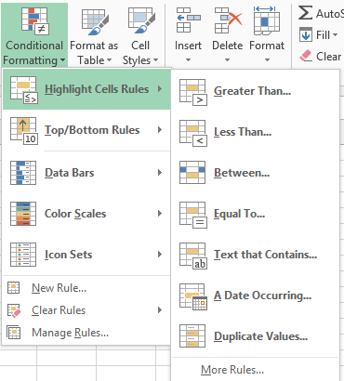
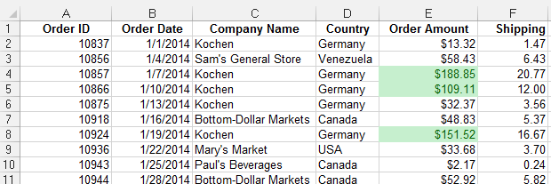

Conditional Formatting
- Select the cell(s) you want to format.
- On the Home tab, click Conditional Formatting
- Select the desired formatting rules

To clear the rules
- Select the cell(s)
- Click Conditional Formatting
- Arrow down to Clear Rules
- Click the appropriate clearing options

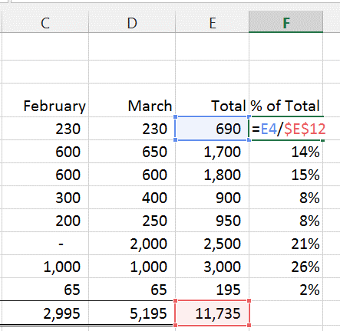

Absolute references
If you don't want a reference to change when you copy a formula to an another cell or worksheet, use an absolute reference. To insert one, place a dollar sign ($) before the parts of the reference that should not change.
Ex: =E4/$E$12
Tip: Press the F4 key while entering or editing a cell address to make it absolute.

To create a formula with a reference to another workbook/worksheet
- Begin typing the formula in the appropriate cell
- Include the “source cell” by switching to the worksheet it is located on and clicking on the cell.
- Press the Enter key (unless additional cell references are needed).

The reference will include the worksheet name, for example: ='1st Quarter'!E4

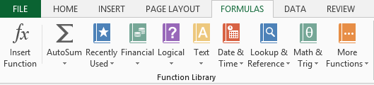
Ways to enter a function
- Type it in the cell
- Use the Insert Function [ fx] button
- Use the buttons in the Function Library under the Formulas tab

Every function has a specified structure. It’s set up like this: Function Name (arguments).
Example: PMT(rate,nper,pv,fv,type)

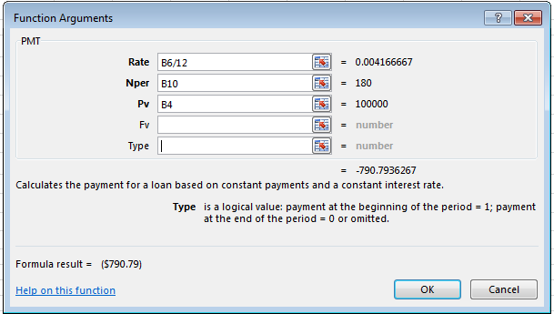

Payment function
- Select the appropriate cell
- Click the Formulas Tab
- Click the Financial button
- Select PMT from the list
- In the Function Argument box, enter the following:
- Interest Rate per period (Rate)
- Number of payments (Nper)
- Loan amount (Pv)
- Click the OK button

Tip: To see the Function Argument dialog box after you have completed entering the function, click the cell containing the function followed by the fx button on the formula bar.

Using VLOOKUP to find values in a table
- Select the appropriate cell
- On the Formulas Tab, click Lookup & Reference
- Select VLOOKUP
- In the Function Argument box, enter the following:
- Lookup_value: Type or click the cell with the value you want to find
- Table_array: Type or click the cell range of the lookup table. This may include an absolute reference.
- Col_index_num: Type the number of the lookup table column containing the corresponding value. The columns are numbered, left to right, starting with 1.
- Range_lookup: Determines if you want to find the closest match or an exact match. For the closest match, type True; for an exact match, type False.
- Click the OK button. The VLOOKUP result will appear in the cell selected.

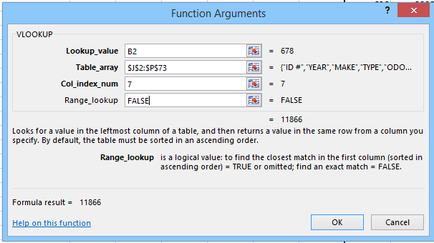
VLOOKUP requires creating or using a “lookup table” containing values you want to find. These values (compare values) must be in the leftmost column. If looking up values in a range (Range_Lookup), compare values must be sorted in ascending order.

