
Microsoft Excel 2010: Advanced Topics
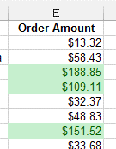
ACTIVITY #1
- Open the Market Orders file
- Select cells E2:E74 (the Order Amount column)
- Use Conditional Formatting to highlight in green all the orders over $100
- Use Conditional Formatting to highlight in red all the orders less than $10
- Clear the Conditional Formatting rules

Activity #2

Part 1
- Open the Budget file
- Enter a formula in cell E4 to calculate the Total amount for Gasoline
- Fill the formula from E4 to E12
- Use Conditional Formatting to add Data Bars to the numbers in cells E4:E11

Part 2
- In cell F4, create a formula to divide cell E4 by E12
- Format cell F4 in the Percent format.
- Modify the formula in F4 to make the reference to E12 an absolute reference
- Copy the formula down through F11

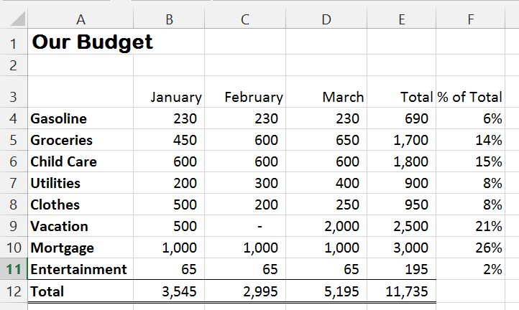

Activity #3:
Complete these steps with the Budget file
- Copy Sheet1 three times to create three new sheets
- Rename the original Sheet1 to 1st Quarter
- Rename the other copies as follows: 2nd Quarter, 3rd Quarter, 4th Quarter
- Change the color of each of the sheet tabs
- Change the values for some of the categories in the 2nd Quarter sheet

Activity #4:
- With the 2nd Quarter sheet selected, type 1st Q in cell G3
- In cell G4, create a reference to cell E4 from the 1st Quarter worksheet.
- Fill this formula down in cells G5:G11
- Go to the 1st Quarter sheet and alter some values. Note how the Total changes.
- Return to the 2nd Quarter sheet to see the changes in the 1st Q column

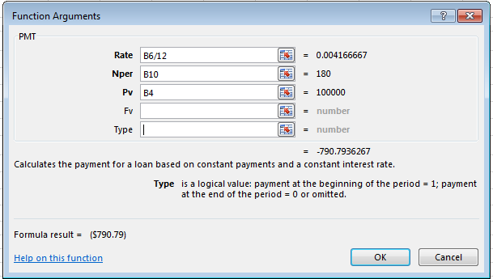

Activity #5
- Open the Loan Calculator file
- Click cell B11
- Click on Financial in the Function Library and select PMT
- In the rate box, type B6/12
- In the nper box, type B10
- In the pv box, type B4
- Click the OK button

Activity #6

Use VLOOKUP to determine the price for each Vehicle ID
- Open the Vehicle Order Example File. The Price List table will be your lookup range.
- Click cell D2
- Click on Reference & Lookup in the Function Library and select VLOOKUP
- In the lookup_value box, type B2
- In the table_array box, type $J$2:$P$73 Hint: don’t forget the colon ( : )
- Determine the column number of the Price column and enter it in the col_index_num box. Hint: ID # would be 1.
- Click OK button
- When the value appears, verify that it matches that in the Price List range.

Filling a table & editing values after using VLOOKUP
- With cell D2 selected, Fill the formula down for the rest of the orders
- Change the Vehicle # for the third order to 897. Notice how the price changes
- Add a new order line with the current date for Vehicle number 1016
- Type your name in the Customer column
- Use VLOOKUP to determine the price and verify that it matches the Price List Table



